EYFS activities - 5 ideas for… a backyard curriculum
By Julie Mountain
Tuesday, May 5, 2020
Ways to take your children’s learning into your nearest outdoors space. By Julie Mountain
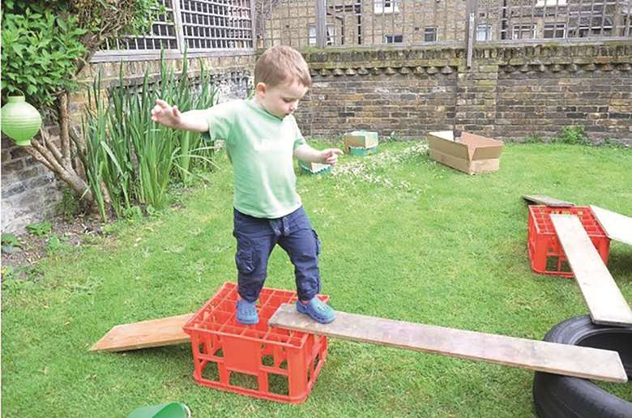
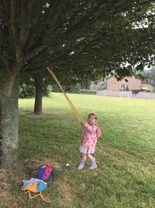
As we adjust to the ‘new normal’, you may be searching for ways to support parents as they balance work and play with their pre-school children at home. Bearing in mind not every family has access to outdoor space, why not share these ideas.
1 PHYSICAL DEVELOPMENT
Make a mini obstacle course using anything you can find – buckets, crates, plant pots, sticks – and encourage your child to practise their Boing (up and down), Whoosh (to and fro) and RolyPoly (rotating) movements.
For example: with your child, Jump/Boing over a stick balanced on two plant pots, then sprint (Whoosh) from one end of the garden or yard and back again; then twirl (RolyPoly) on the spot, feeling the wind rush through your hair. A long length of elastic is a brilliant way of supporting resistance strength – hook it around a tree or fence post, and puuuullllllll!
2 MARK-MAKING
Building upper-body strength and resilience helps children control the movements of their upper and lower arms, wrists and, ultimately, their fingers and that pencil grip. The backyard is the perfect place for colossal mark-making – using whatever you have to hand.
When not constrained by a pencil and an A4 sheet of paper, children might create with water and a yard brush or paint roller, make a bird shape or the word itself using bird seeds, design a maze with string… almost anything can be repurposed to allow children to express themselves.
As this kind of mark-making is temporary, do remember to photograph it to reflect on later (especially if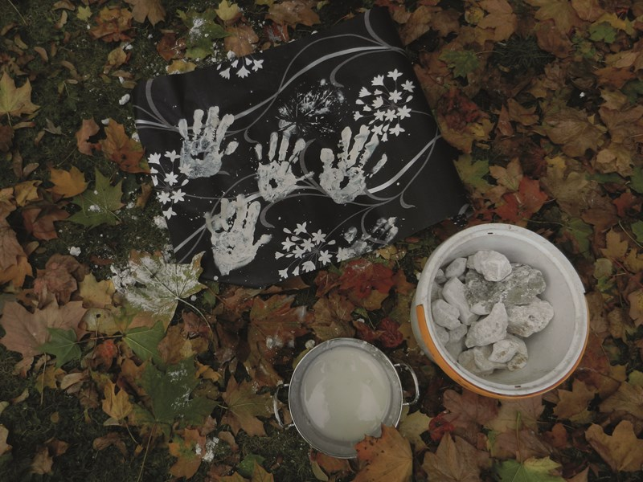you get to watch birds eating your bird seed art).
3 NUMBERS AND SHAPES
Make a simple tally chart with shapes drawn along the top (for example, a square, rectangle, circle and triangle) and numbers from zero to ten written randomly across the paper – if you know you’ll find an unusual shape, include that too. Explore the garden (or a room indoors, or your street) searching for examples of each shape.
Count the number of incidences of each shape and record that number: the child might do this by writing the number inside the shape, or ticking the number they believe is correct, or drawing a line from the correct number to the matching shape. Which shape is most common in your backyard?
Which was the biggest example of a shape? What maths-related words do you hear the child using? Encourage them to use ‘more or less’, ‘bigger or smaller’ and synonyms for the shapes (for example, ‘round’, ‘ball’, ‘sphere’, ‘globe’ and ‘circular’).
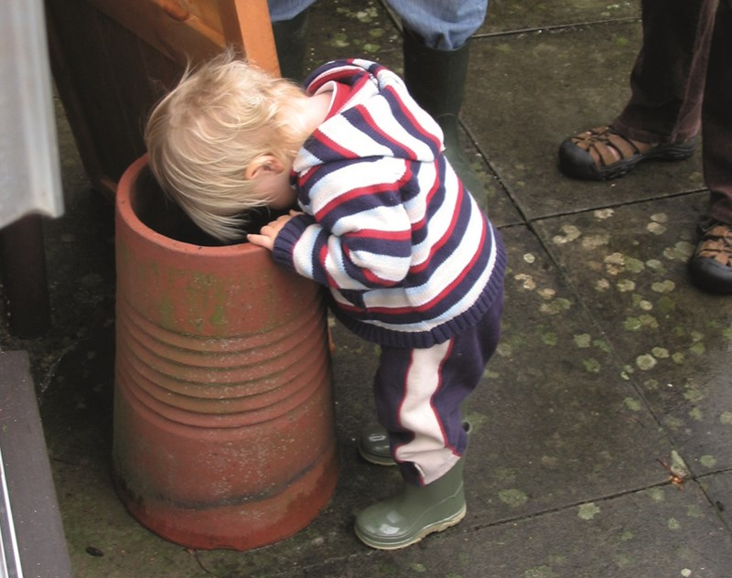4 IN NATURE
If you can get to a patch of grass, spend some time lying on it together, watching the clouds. Take a moment to feel the coolness of the grass, and its ticklishness, on your skin. Inhale the aroma of grass and soil – what else can you smell? How can you know which way the wind is blowing? What can you see in the sky? Roll onto your tummies: what else can you see growing through the grass? What does it feel like to have a worm’s eye view of the world?
5 OUTDOOR STORIES
Rig up a story cave in the garden – all you really need is a couple of old sheets or blankets flung over a box, a clothes drier, two chairs or a washing line. With your child, choose stories that are set outdoors and share them in your story cave.
Bring action into the tale by acting out parts of the plot using whatever props you can scavenge outdoors. There are lots of stories that work well outdoors, but my favourites include Stick Man, The Story of the Little Mole and, of course, We’re Going on a Bear Hunt.
And finally…
- Test out new activities yourself, noting potential hazards, pinch points or other obstacles.
- If you don’t have your own backyard or garden, these activities can be transferred to a patch of grass or even onto the pavement as part of your daily exercise together.
MORE INFORMATION
Parents might also welcome ‘5 ways to…explore your neighbourhood’ at: www.nurseryworld.co.uk

