REMOTE LEARNING DAY 5
Self-help
~ Snuggle up for story time. Ask your child to choose your favourite book and encourage them to hold the book (the right way up) themselves and turn the pages one at a time. They could sit their cuddly toys/dolls down for story time and have a go at “reading” to them.

Gross motor
Make a PE circuit… hopping, star jumps, running on the spot, crawling like a dog, skipping. Your grown up could even use a stop watch to time you!

Fine motor / muscle stamina

Scissor skills (great for hand eye coordination and to enhance finger strength) – Practice holding scissors correctly and cutting along wriggly lines, zig zags, circles etc. Find your favourite pictures in colouring books and old birthday cards/Christmas cards and cut them out. Stick them in a scrap book, make a collage or even some bunting!

Number hunt
Have fun finding the door numbers in the story ‘Hairy Maclary’ (see link below) Talk about why houses have numbers.
What number is on your front door? Can your draw/colour your front door and have a go at writing your door number? Go on a walk and have a look at all of the different door numbers in your area. How many numbers can you identify?
Challenge: Find a door that has the same number as your age. Find a door with the same number as your door. Use a camera to take a photo!

Phonics Play app
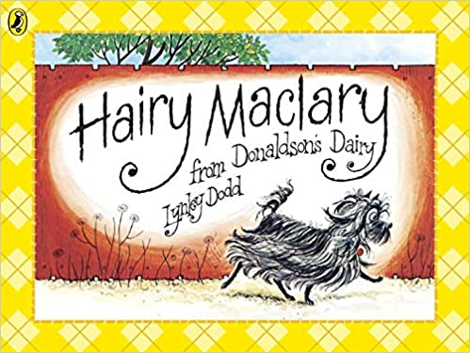

Story / song time
~ Hairy Maclary – Listen to Hairy Maclary read by Mrs Howell. Can children join in with repeated refrains and identify the rhyming words?
Welcome to Newburn Manor Nursery School (newburnmanor-nur.newcastle.sch.uk)

