REMOTE LEARNING DAY 10
Self-help
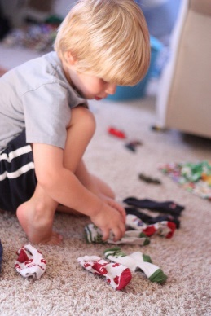
Can you match you socks? ~ I wonder if you can be super helpful and help your grownups to sort your washing out? We know how clever you all are! Can you find all of your clean socks and find their partners? Make sure you look carefully at the colours and shapes on them to help you. If you can match yours, maybe you could match your grownups socks, or your brothers/sisters.

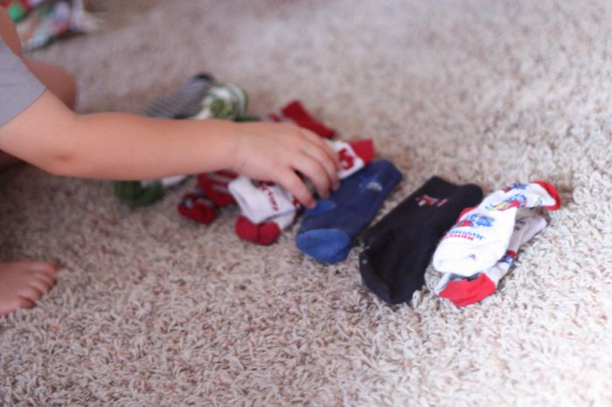

Gross motor
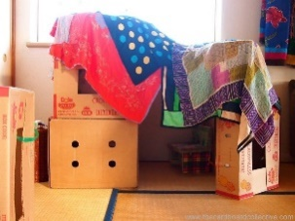
Who is feeling tired after our busy job of sorting socks? ~ I think you’ll all be ready for a lovely quiet story. But before we do that have you got somewhere comfy to sit? I wonder if you could make a den… You don’t need a lot of things; a den can be made out of anything! Blankets, cushions, chairs, or boxes. See if your grownup can help you… Make sure you have lots of FUN!
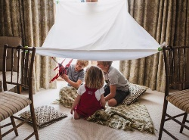

Story Time
Are you all snuggled in ready for a story…? You may need to use a torch in your den if it’s dark!
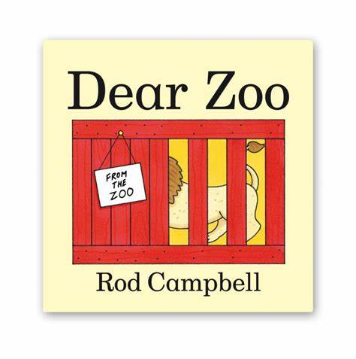
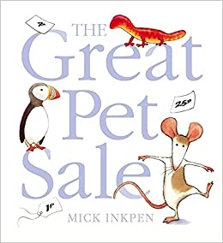
Don’t worry if you haven’t got any books, simply look on our Facebook page to listen and watch one of our favourite stories. We have been looking at and talking about Pets, so today’s story in Nursery is ‘The Great Pet Sale’ and for playgroup ‘Dear Zoo’. Discuss with your child all the animals in the stories, which animals would make a good pet? If yes, why? If no, why not?

Welcome to Newburn Manor Nursery School (newburnmanor-nur.newcastle.sch.uk)

Fine motor / muscle stamina
Did you enjoy the story? We knew you would! ~ We saw quite a few different numbers in ‘The Great Pet Sale’ didn’t we? I’ve just thought of something fun that we could do now (or later on if you are still tired!)
We could turn our dens into pet shops! You might have some pretend money at home or your grownups may have some real pennies that you can look at. What numbers can you see on the pennies? Can you sort them into different groups (1p, 2p, 5p, 10p, 20p etc) How many coins do you have in each group? Remember to touch each coin as you count and say the number out loud. You could choose some of your toys to sell in the pet shop, how many pennies do your grownups need to buy a pet? I hope they have enough money to buy their favourite pet!

We hope you have lots of fun with today’s jobs! We can’t wait to hear all about it.
