REMOTE LEARNING Tuesday 23rd Feb
Self-help
I’ve got a very tricky job for you today! Some of you have not been to Nursery for a long time… I wonder if you can remember what to do when you need to blow your nose?
The weather has been super cold over the past few weeks; this may have given some of you a cold. A cold is when you have a runny, sneezy nose and you may have a little cough too. Can you remember what we do and say at Nursery? That’s right… ‘CATCH IT, BIN IT, SPRAY’

Don’t forget to cover the whole of your nose with the tissue and give a little blow. Then you need to squeeze your fingers together to wipe your sneeze away. Now, remember you must ALWAYS put your tissue straight in the bin or toilet, then give your hands a lovely good wash. We know you are all superstars at washing your hands now… remember to do dancing hedgehogs! If you are not near a sink to wash your hands, I’m sure your grown-ups have some hand sanitiser that you can use, to make your hands nice and clean.

Fine motor/Muscle Stamina
Are you ready to get those little fingers warmed up?
Can you remember before half term, Mrs Henderson made some AMAZING pictures using lots of things that she found in her garden? Well today, we would like you to do something different with the bits that you can collect from outside. Today, we would like you to use your fingers for tearing, or (if you have some) use scissors to cut. Some of you may have straws or hole punchers in your house?
Have a little look at the things you have found and talk about what they feel like; do they have a smell? Next you need to have a think about which tools you could use for each object. Some things may be tougher to cut (like small twigs) and some things you may not be able to snap or cut at all! If you would like to, you could make a picture with these bits. Make sure you do this job with a grown-up, as you need to stay safe with the scissors and other tools!
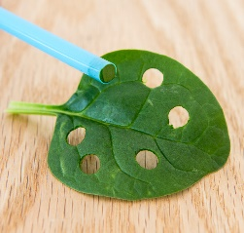
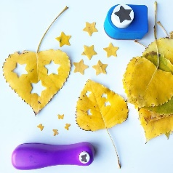
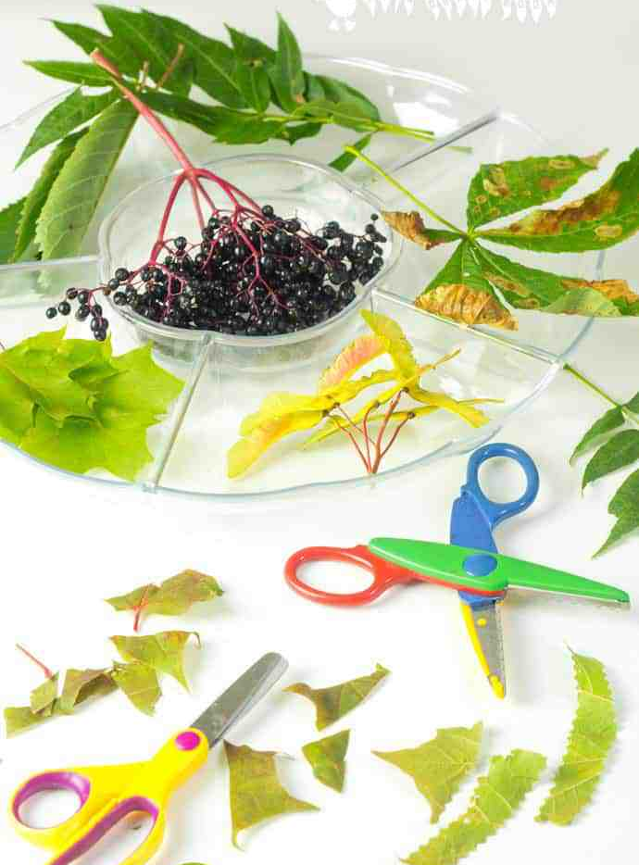

As we have mentioned before, activities involving fine motor skills are so important for developing muscle strength, which will help your child when learning to write.

Story time
I bet you are all tired now and need a little rest? ~ I’m going to give you a few clues as to which story we are going to be learning about this week. I know yesterday you learnt that it is almost Spring. In this season lots of baby animals are born. There are 3 animals in this story and they like to munch on lovely fresh green grass. There is another character in this story… a big ugly troll! Can you guess what the story is… it is one of my favourite books…‘The Three Billy Goats Gruff’
Welcome to Newburn Manor Nursery School (newburnmanor-nur.newcastle.sch.uk)
Click the link on our Facebook page to listen to the story. See if you can remember the story and tell it to someone in your house.

Song time
Click on this YouTube link to listen to and join in this song about The Three Billy Goats Gruff Three Billy-goats - YouTube

