REMOTE LEARNING DAY 4
Self-help
~ Outdoor clothing on and off
Begin with encouraging your child to offer their arm to put in a coat sleeve. Progressing to your child helping with their clothing eg. puts on hat, unzips coat. Then developing to dressing with help eg. put arms in coat when held up, pull zip up once fastened at bottom. And finally, the reward, after all of your encouragement and support, will be that your child can get ready for outside time all by themselves!
If you feel like your child (and you?!) is up for a further challenge then get them to put on mittens all by themselves and if you’re feeling patient, why not try gloves on by themselves?!

Gross motor
Woohoo it has been snowing! Play in the snow…
Make snow angels, build a snowman, roll and throw snowballs (who can roll the biggest? Who can make the most? Who can throw theirs the furthest?)

Fine motor / muscle stamina
~ Finger play/Number rhyme -5 LITTLE SNOWMEN FAT (see link below)
Use your fingers to represent how many snowmen you have each time.
“5 Little Snowmen Fat,
Each with a funny hat.
Out came the sun and melted one,
What do you think of that? Down, down, down, down
4… 3… 2… 1… 0…

Ice Challenge
Freeze some little toys in water filled containers either outside or in the freezer. Perhaps even Elsa has frozen them?? Talk to your child about how you can get them out. This activity is great for problem solving and trying out ideas. Your child might suggest using a hammer, some scissors etc or they might suggest trying to melt the ice. How might they do this? They might suggest leaving it near a radiator, using a hairdryer or even using their warm hands to help melt the ice. Watch what happens as the ice melts. Model language such as frozen, ice, freezing cold, slippy, hard, melt, drippy, water etc. The children will be so pleased when their toys are finally free!

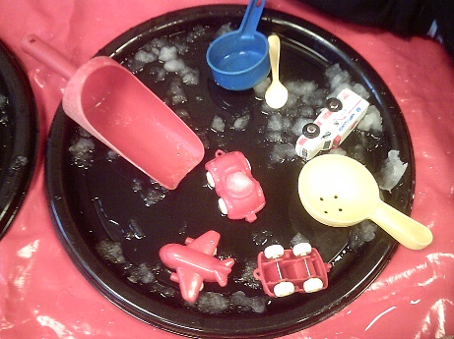
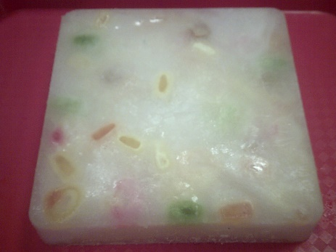

Ice play – scoop ice onto a tray and explore by scooping, pouring, scraping etc. Let children use their imaginations and play in an ‘ice world’ with small animals and vehicles etc.
Story / song time
~ Song time – 5 Little Snowmen Fat https://www.youtube.com/watch?v=yaAkFVLJTSQ

