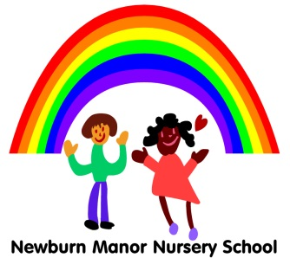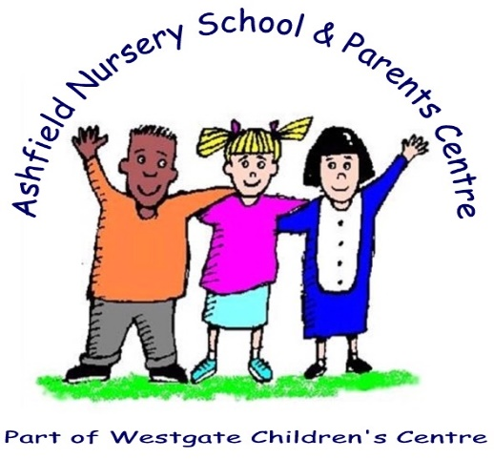

22/05/2020

Dear Parents and Carers,

Thank you to all of our families who have replied to let us know what they feel needs to be in place for a possible return to school in June 2020. We will ensure all your questions are answered when we share our plan with you.

We have been working through all of the government guidance to make our setting safe enough for children to return to school on 1st June 2020. Unfortunately, we have not been able to secure a safe opening for this date yet.

We are awaiting further government and local authority guidance before we can complete our plans to invite more children back to school later this term.

Once we have completed all of the changes required, including consultations with staff and unions, risk assessments and safety checks, we will be in touch to let parents know what the new systems for opening might be.

We hope you are all keeping safe and well during these challenging times.

Please check our school website and facebook for regular up-dates and for ideas that you might like to work on with your children at home while Nursery and Playgroup are closed. Our website address is

[www.newburnmanor-nur.newcastle.sch.uk/website](http://www.newburnmanor-nur.newcastle.sch.uk/website)

If you have any queries, comments or questions, please contact me via our admin address at

[admin@newburnmanor-nur.newcastle.sch.uk](mailto:admin@newburnmanor-nur.newcastle.sch.uk)

Just to confirm, we will ***NOT*** be opening on 1st June 2020 for all children. We will be open as usual for children of key workers and vulnerable children who have been attending already. You must contact us if you are a key worker or have a vulnerable child and require a place.

With thanks for your understanding, patience and support,

Yours faithfully,

Kay Mills

Co Headteacher

Newcastle Federation of Newcastle Nursery Schools

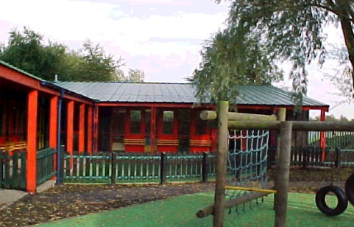

**Monkchester Road Nursery School**

**Ashfield Nursery School and Al2gether @ Ashfield**

**Newcastle Nursery Schools’ Federation**