REMOTE LEARNING – Thursday 28th January
Good morning everyone! We love Traditional stories in nursery so we thought we’d read you one today. It’s…..The Gingerbread man. You might have heard it already! Perhaps you can tell your grown up what you remember. Traditional Tales are great for teaching children the structure of a story so after listening to the story (read by Mrs Henderson) Welcome to Newburn Manor Nursery School (newburnmanor-nur.newcastle.sch.uk)have a go at talking about what happens at the beginning, the middle and the end! Our favourite bit is, of course, joining in with the repetitive language!
Run, run as fast as you can……
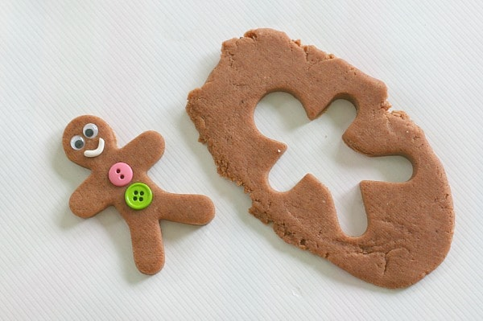
Playdough Recipe
- 2 cups plain flour (all purpose)
- 1/2 cup salt
- 3 tablespoons any oil
- 2 tablespoons cream of tartar
- 1 cup of boiling water (added gradually)
- 1 tablespoon ground ginger
- 2 tablespoons ground cinnamon
Next, you could help your grown up make some playdough. This is special playdough because it’s ginger playdough and smells amazing!! Remember, you can’t eat it though because you might get a poorly tummy! Use a gingerbread man cutter or roll and cut your dough to the shape you want. Decorate it with pomp poms, sequins, buttons, raisins etc to make a face! Now you have your very own gingerbread man to help retell the story! I wonder if you can use some of the words from the book?
After that you could follow the link below to do some Dough Disco….
Disco Dough- Gingerbread Man - YouTube

Self-help
It’s the fourth day of our ‘LUCKY DIP’ game (see Monday’s Remote Learning sheet for a reminder of what the game is)
I bet you’re getting very good at doing lots of these things all by yourselves now. We are so proud of you! What big girls and boys you are! Remember, grown- ups, feel free to add in your own activities depending on the needs of your child.

Fine Motor/ Song time
It’s Song box time again! Watch Mrs Barnard sing a new song to us (Welcome to Newburn Manor Nursery School (newburnmanor-nur.newcastle.sch.uk)). Today’s song is ‘Two Little Dickie Birds’. This is perfect for Bird Watching week! Get your Peter Pointer fingers ready to help join in with the actions! You may have started to make your own ‘Finger Play song box’. How about making two birds to go inside! Cut card or cardboard into the shape of birds (don’t forget the pointy, triangle beaks) and decorate with feathers, cotton wool and googly eyes. Little cardboard compartments from inside of an egg box are ideal too!

Silly Soup – RHYME
Mrs Howell is making Silly Soup for her lunch today (Welcome to Newburn Manor Nursery School (newburnmanor-nur.newcastle.sch.uk)). It’s very silly indeed! A rock, a sock, a pan and a man are just some of the strange ingredients she is using to make the soup. This is a great rhyming activity to help children identify rhyming pairs. After watching the activity, you could have a go at making some of your own Silly Soup using objects around your home! Draw pictures if you’re struggling to find anything suitable.

Gross Motor/Maths
Time for another Maths game! This time we’re going to play good old Hopscotch! Either use large bits of numbered paper taped to your floor inside or use chalk out in your garden. The numerals don’t have to be 1-10… you can put any numbers you like on your hopscotch depending on which ones your child needs to learn. Aim for a few that your child knows already with a couple of new ones. You could even just repeat the same two or three numbers if your child is just starting to recognise numerals.
The main thing is to have lots of fun!

