REMOTE LEARNING - Monday 25th January

Today is Monday, the start of a new week so it’s time to learn about something new ……..
Did you know that it’s National Bird week?
That’s why we’re going to learn all about ……….
BIRDS!

With your grown up, use a computer, phone, or ipad to learn all about birds!
The RSPB website is perfect for this.

On there you will find:

*Birds to look out for when bird watching*
https://www.rspb.org.uk/fun-and-learning/for-teachers/schools-birdwatch/birds-to-look-out-for/

*A live feeder camera (great for guaranteed bird sightings*
if bird watching from home isn’t successful!)
https://www.youtube.com/watch?v=z2YXRazll4Y

*A story to download - Bouncy Blackbird – about what foods birds can eat*
https://www.tes.com/teaching-resource/bouncy-blackbird-story-to-teach-young-children-what-different-foods-birds-eat-11366760

Fine motor/Muscle Stamina
Make a bird feeder
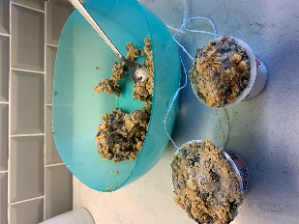
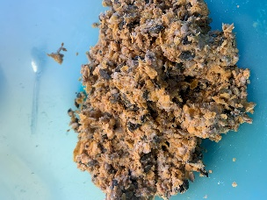
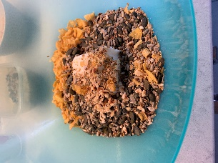
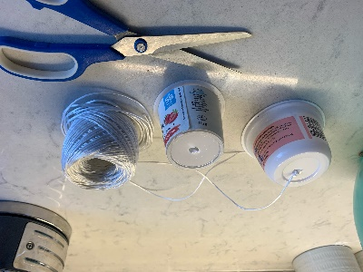
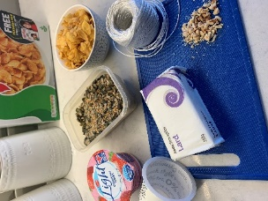
Mrs Henderson has been busy at home making a bird feeder for the birds in her garden!
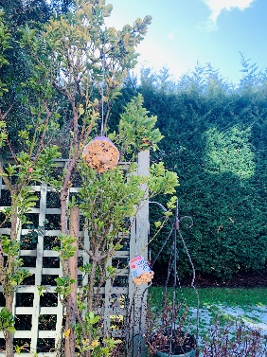

You will need LARD and some of these things:
fruit, bird seed, honey, cereal (hoops are perfect), pinecones
and finally you’ll need some utensils for mixing and making and some containers for the bird food and string to hang the feeders from the trees.

Self-help and Gross motor
We have been very busy at home practising how to do lots of things all by ourselves.
Let’s play a game everyday this week called ‘LUCKY DIP’……..
Print off the pictures below (don’t worry if you can’t, you can draw them instead?), fold each picture up and put them all into a box. Then each morning when you get up, give the box a shake, open it, pick out a picture and do that special job!
Make your bed  This Photo by Unknown Author is licensed under CC BY-SA | Brush your teeth | Wash the dishes | 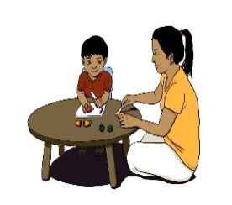  Prepare a healthy snack with your grown up  This Photo by Unknown Author is licensed under CC BY-SA-NC
Take off/put on your top  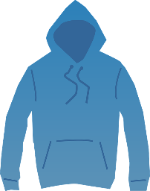 | Take off/put on  your coat | Take off/put on  your shoes  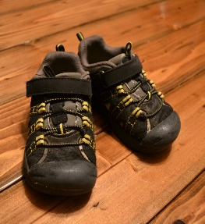 | You choose!

Song time
Song box time
I’m feeling excited because I’ve made a new song box for you all, it’s a ………
FINGER SONG BOX!
To find out what the new songs are and to listen to me sing them, please go to the website or Facebook.
There are two songs to learn today and one song each day for the rest of this week so get those fingers ready and pop your singing voices in ……
ready, steady and off you sing!

Welcome to Newburn Manor Nursery School (newburnmanor-nur.newcastle.sch.uk)

