Remote Learning – Friday 12th February

We’re feeling very excited today because it is Friday AND it’s the last day of home learning for this half term. Next week you have a whole week off for the half term holiday!
Children, you have done SO well at home and we’re very, very proud of you! We would also like to express our appreciation to parents too as we know it’s not easy juggling everything! A big thank you to all of you!

We have some more pancake jobs to do today in preparation for next week (or earlier if you can’t wait try some pancakes…like me!)
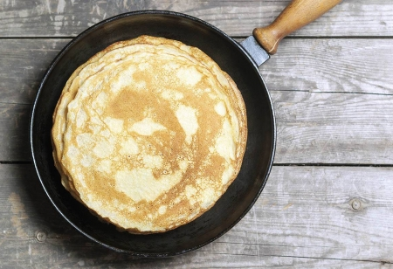

Here is a simple pancake recipe...
Easy pancake recipe to cook with kids - CBeebies - BBC
Children, I wonder if you can have a go at counting out how many eggs you will need. Then you can help your grown-ups use the scales. What numbers can you see? Have a go at cracking the eggs, pouring the milk and oil and then whisking the batter. These are all great skills to learn! You need to concentrate and use your looking eyes. Try and be as careful as can! Your grown up will help you pour the batter into the hot frying pan because this is a dangerous job. We don’t want you to get burnt! Can you hear the batter sizzle? When one side of the pancake is cooked, you need to flip it. This is my favourite bit and so fun! Flip it up and catch it! How many times can your grown up flip it up and catch it? 1,2,3,4…. Don’t let it stick to the ceiling like Daddy Pig from Peppa Pig!
Peppa Pig - Pancakes (full episode) - Bing video
Have a think about what topping you’re going to put on your pancake. There are lots of toppings to choose from. Some people like lemon juice with sugar or chocolate spread with strawberries and banana. Other people prefer golden syrup on theirs and some people like theirs plain! You could try different toppings and decide which is your favourite. It would be really fun to try something brand new that you’ve never tasted before! Have a go at drawing your pancake with your favourite topping and send a photo to us.

Here is a pancake poem! Do you know what a poem is? It’s a little bit like a story-song. This poem has rhyming words. Can you hear them? I love to do actions when reading this poem too! What actions can you think of for mixing, pouring, frying and tossing?

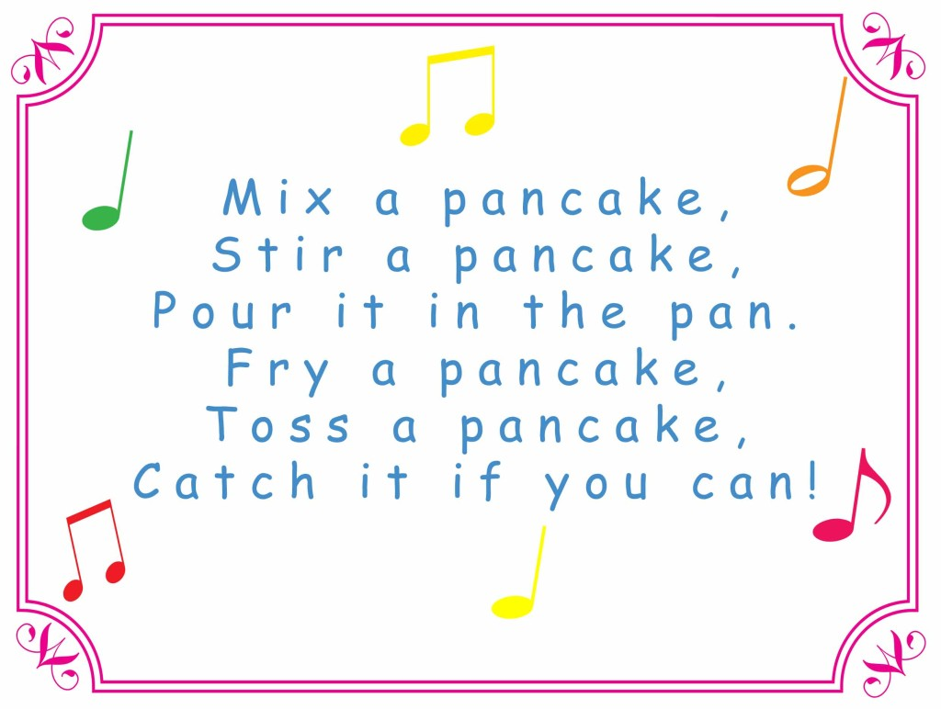

Have fun everyone and HAPPY HALF TERM!!

