REMOTE LEARNING Friday 22nd Jan (DAY 13)
Happy Friday Everyone!
Well done for getting through another week. We are missing you all lots and are very proud of you and all of your lovely work!
Self-help
We’ve got a fun job for you to do today. It’s a really grownup job, do you think you can help? ~ We’ve seen how clever you have been so far with your jobs, so we know you’ll be fantastic at this one! Today we’d like you to help your grownups with the washing up. We know how hard your grownups work at looking after you all, so we thought it would be nice for you to help them. For this job, you don’t need much. You may be able to use your kitchen sink if you have a little step to reach, or you could use a small bowl or pan filled with soapy water. You could use a small cloth, or a flannel and you may have a tea towel you could use to have a go at drying your dishes. What did you have for breakfast this morning? I had a lovely warm piece of toast with strawberry jam on and a cup of tea. After I had eaten it all up, I used my sponge to wash my plate until it was lovely and clean. I had to do it slowly, so that I didn’t splash all of the bubbly water out of the sink! We don’t want slippery puddles on the floor! Then I slowly washed my knife. I had to be very careful, as knives have a sharp edge and I didn’t want to cut my finger. Once everything was sparkly and clean I used my tea towel to give them a little dry. This is a bit tricky, as you have to hold the towel in one hand and the plate in the other. Don’t worry if you need your grownup to help you, or you could leave your dishes on the side to dry!
We can’t wait to hear how you get on with this job…what helpful boys and girls!

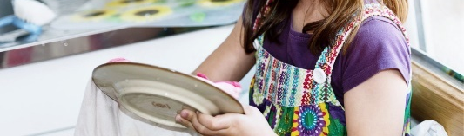
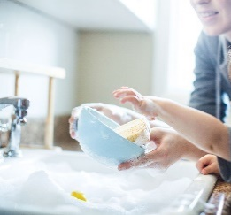
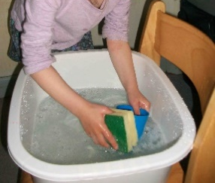

Fine motor/Muscle Stamina
We’ve thought of another job that we think you would be good at ~ We know that you have helped your grownups to match your socks with their partners, but can you help them to hang your socks on a washing line? Some of you may need to use pegs to hang up your washing. Pegs are really tricky to use, as you need to squeeze your thumb and finger together to open the peg. We know it is a bit chilly outside for hanging your washing out, so maybe you could practise using pegs inside?
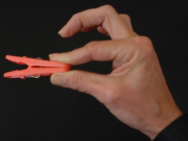
Activities involving fine motor skills are so important for developing muscle strength, to help your child when learning to write.

Gross motor/Song time
Now it’s time to wake up our bodies! Yesterday we looked at ‘Animal Boogie’ and today we are going to go ‘Walking through the jungle’ ~ In this story, you will be moving your bodies in lots of different ways through the jungle. On your way you will see lots of animals. Can you think how they might move too? Open this link to watch the story and join in with your actions. https://www.youtube.com/watch?v=plvY0quSyJg

Now, before we move onto our next job, I wanted to give you a few clues as to what we will be doing.
Did you notice what the little girl was doing at the end of the story? That’s right… she was running home for supper. Do you know what supper is? Supper is a meal that you might have at night time. I know someone else who likes to have supper… and he is also from the Jungle… Shall I give you a clue? He is orange with black stripes… Yes, you’ve got it, it’s a Tiger!

Storytime
Now find somewhere snuggly to sit, as we are going to listen to one of the teachers’ favourite stories… A Tiger who came to Tea~ Find the link to our website or visit our Facebook pages to enjoy watching this story. Think about what you would make the Tiger for Tea if he was to come to your house. Would he be able to help you wash the dishes! Welcome to Newburn Manor Nursery School (newburnmanor-nur.newcastle.sch.uk)

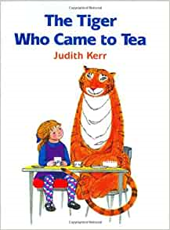

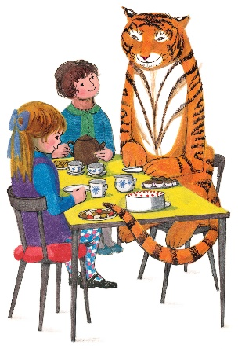
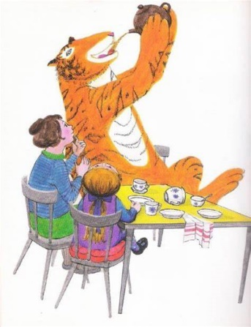

We hope you all have a wonderful weekend! Remember to let us know what you have been up to, we love showing all of your friends at Nursery

