Remote Learning – Monday 8th February
Hello everyone, it’s the start of a brand new week and we have some lovely things planned for you all! Did you know that the month is February? There are some exciting days in February that we can celebrate with our family. Can anyone guess what they are? They are Pancake Day (where you get to eat yummy pancakes) and there is Valentines day! These will be happening next week (in half term) but we can plan for them this week so look out for some Valentines and Pancake Day themed activities as the week goes on!
Fine Motor
Last week we were learning all about touch and how things feel! Today we are going to be thinking about our sense of smell. Which part of our body do we use to smell? Have a go at painting….but not with your usual paints! Perhaps a grown up can mix a little water in hot chocolate powder, flavoured tea, curry powder, gravy, milkshake powder etc and you can paint with those!! Get your noses ready to sniff and smell! I wonder what your special ‘paints’ will smell like! Which smell will you like the most/the least? What are you going to paint? Patterns-big/little circles, zig zags, wavy lines? You name? Some new letters? A person? A flower? A car? Your favourite toy? Please let us know and please send us some of photos of your fabulous paintings!
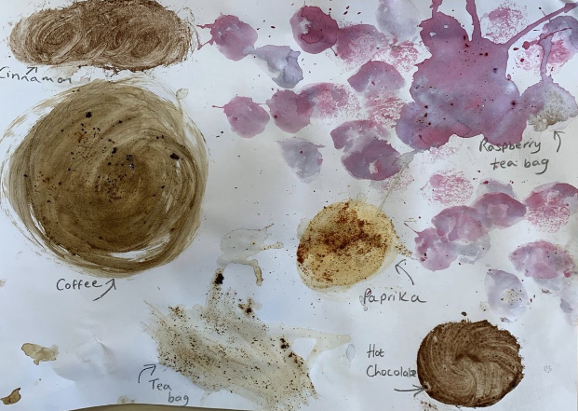

Self Help
Talk about personal hygiene and why getting washed it so important. It is important we care for our bodies, hair and teeth by getting lots of baths and brushing our teeth to wash away, mud, food and germs. It also stops you from getting smelly! Can children have a go at washing themselves independently the next time they’re in the bath? They might even be able to have a go at putting a small drop of soap onto their sponge. Don’t forget to rinse the soap off so you don’t get itchy skin…and don’t forget to wash behind your ears children!

Story/Song
Listen to the story of the smelly bear that really needed a wash! There are some fun bath time sings to sing along to too!
Big Smelly Bear Book Read Aloud for Story Time! Educational! Fun! - Bing video
The Bath Song | Original Kids Song | Super Simple Songs - Bing video
Bath Song | CoComelon Nursery Rhymes & Kids Songs - Bing video

Maths/Gross Motor
Roll a dice and count the dots. Maybe your grown up will show you what the numeral looks like. Can you do that many jumps…or twirls…or pats on the head etc? You might think of some of your own actions. Remember to stop at the right number!

