Remote Learning – Monday 22nd February
Hello everyone, we hope you had a lovely half term break. Hopefully you had some lovely walks and managed to have some fun playtimes in a park or your garden. I’m so pleased to see the weather is getting a bit sunnier and brighter now. Winter is ending and Spring is well and truly on its way which makes me feel very happy! This half term we will be looking for signs of Spring and will be learning about growth and change. Some of you might have noticed the warmer weather already and may have spotted some Snow drops growing? If you haven’t then keep your eyes peeled for them the next time you are out on a walk. You could use a camera or phone to take a photo of them then have a go at drawing them when you get back home! Notice how the long petals droop downwards, almost like the shape of little bells!

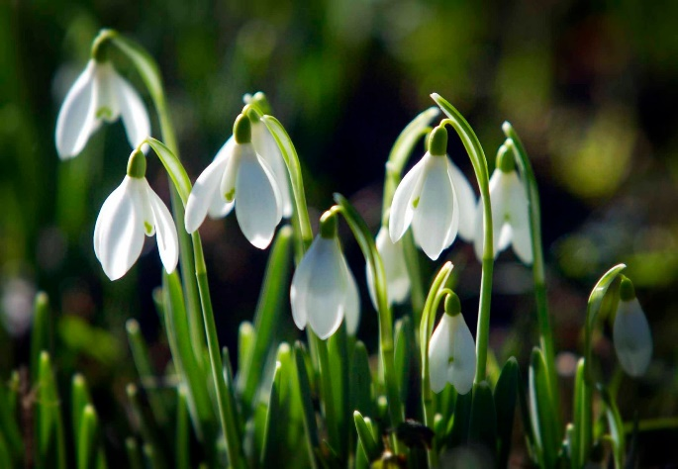
Internet Safety
Laptops, I pads and phones are becoming a massive part of modern life and it’s important our children know how to stay safe online. This is a lovely little video teaching us how to play online safely…
Smartie Penguin HD | Internet Safety Story for Early Years - YouTube

Here is a reminder of some fun and educational apps and websites we recommend:
- Phonics Play
- Reading Eggs
- Teach Your Monster How To Read
- CBeebies Stories
- Top Marks
- Number Blocks
- Alphablocks

Fine Motor/Number Song
Lots of the grown-ups in nursery have been baking during half term. I wonder if you have too?
Watch Mrs Howell sing a currant bun number song that we sometimes sing in nursery to help us learn how a number/amount changes when we take one away each time. Sometimes we even match the correct numerals to show how many current buns we have.
Welcome to Newburn Manor Nursery School (newburnmanor-nur.newcastle.sch.uk)

Have a go at home. You could pretend your fingers are currant buns or you could make some! Play ‘baker shops’ and add a till and money for even more fun! To make it trickier you could make and sing about 10 currant buns! Have a look below for some ideas…
SALT DOUGH CURRANT BUNS
- Mix 2 cups of plain flour and 1 cup of salt together in a large bowl.
- Add 1 cup of water. Add it in slowly as you may need less.
- Knead the mixture into a dough.
4.Roll into currant bun shapes then let it dry out over night or put them in the oven for ten seconds at a time. This won’t take long at all!
5. When cool it’s time to paint them. Don’t forget to paint your currants and cherry on the top!

PLAYDOUGH CURRANT BUNS

Add some cinnamon and decorate with currants/pom poms/buttons etc. You could even pop your play dough currant buns into cupcake cases.
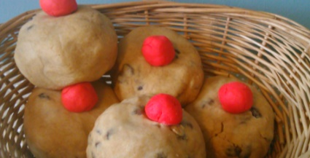

ROCK PAINTING

Paint some large pebbles or stones and turn them into delicious looking currant buns! Don’t forget to seal the paint with PVA glue or varnish.

OR, of course, you can make some real ones! Yummy!
Rock Buns - BBC Good Food

Have fun!!!

