Newcastle Nursery Schools’ Federation

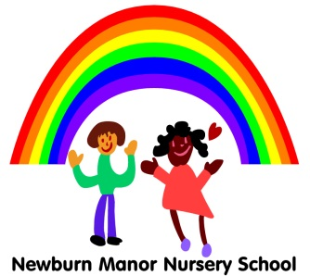
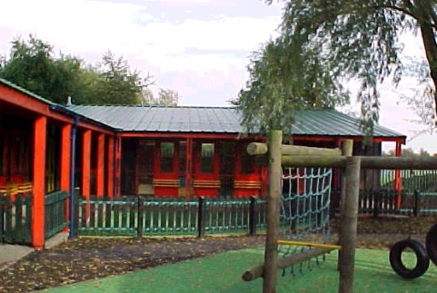
Monkchester Road Nursery School

Ashfield Nursery School and Al2gether @ Ashfield

14.5.2020
Dear Parents and Carers
Following the announcement from the Government this week about Nursery aged children returning to school on June 1st I wanted to update you on the current situation.
We understand that we all want to get back to normal, where children can see their friends and enjoy playing and learning in nursery, but in order to do this we have to consider the wellbeing and safety of children, staff and parents.
We have started to think about the possible re-opening of our school and are in the process of looking at completing risk assessments in partnership with the Local Authority and Public Health. As you will understand one of our main concerns is the inability of Nursery aged children to socially distance from each other or staff. We are awaiting further clarity from the Government to be able to answer the many questions we have about this situation.
When we do return it will be phased and gradual and we will need to ensure you have confidence in the arrangements that are in place. Once we feel we have the correct measures in place for a safe to return to school we will share our plan with you. Returning your child to school during these uncertain times will be your choice as a parent.
I am aware you do not have the details yet but to help us in our planning if you can let us know if you would like your child in school or if you would prefer to keep them at home then please contact us at admin@newburnmanor-nur.newcastle.sch.uk Just to reiterate – making this decision will be difficult as you do not have the full details yet, but if you are able to give us an indication this will help.
As I am sure you will agree our priority, as always, is to ensure whatever measures we take the safety of children, staff and parents are paramount.
I will be in touch again in due course to update you on the situation. In the meantime, if you have any questions or concerns please do not hesitate to contact us at admin@newburnmanor-nur.newcastle.sch.uk
Yours sincerely,
Kay Mills

Co-Headteacher Newcastle Nursery Schools Federation

