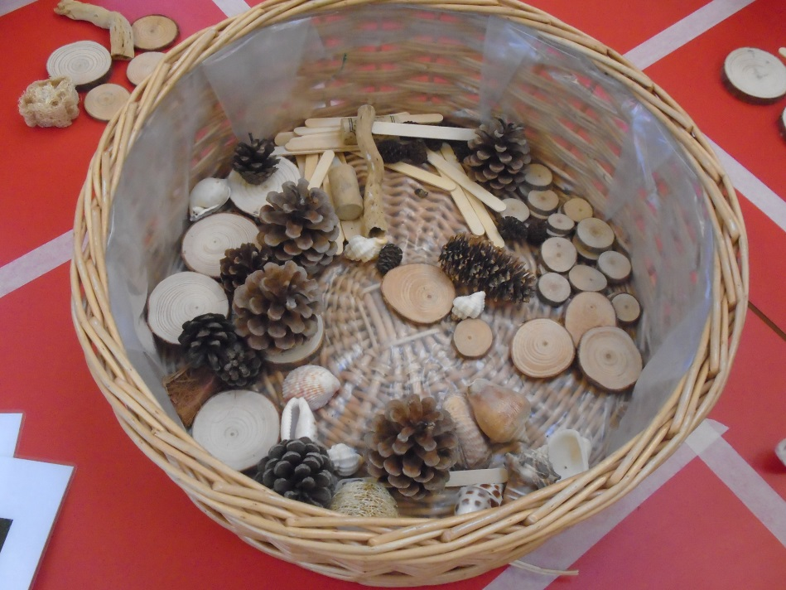

EAD: Transient Art

The children used a basket of natural materials to make their own pictures.

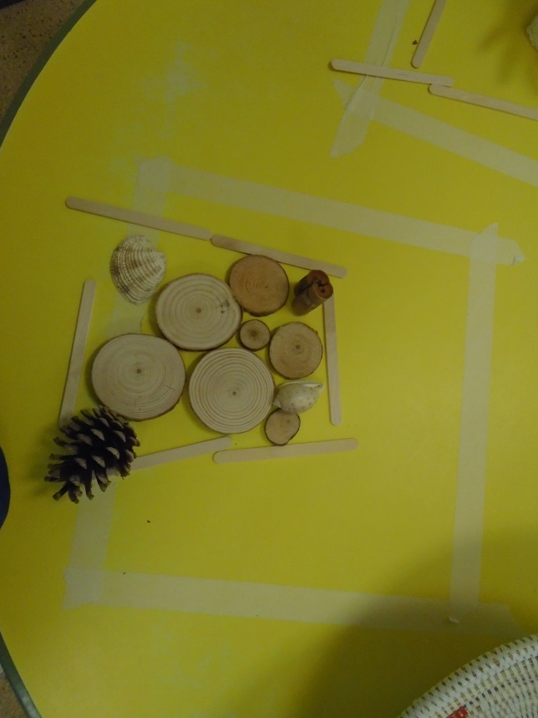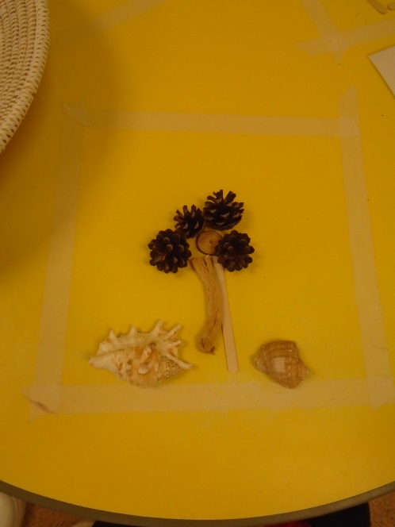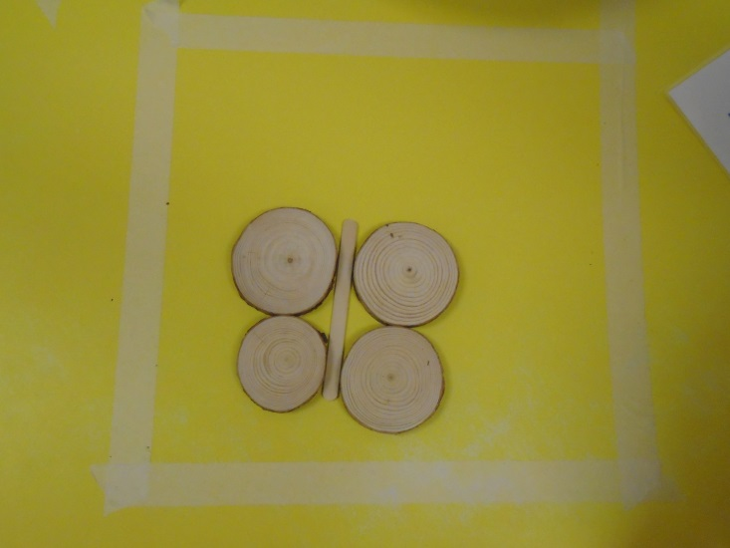

This child chose to make a house using a variety of different materials

One children created this tree, using a log, pine cones and some shells

Some children decided to make butterflies