REMOTE LEARNING - Tuesday 26th January

Good morning everyone! Bird watching week is in full swing and we hope you enjoyed yesterday’s activities. Mrs Henderson’s bird feeders were a hit! She enjoyed watching lots of birds fly into her garden and nibble at the treats she put out. Cornflakes seem to be their favourite! Mrs Howell threaded Cheerios and fruit onto twigs and lots of little Blue Tit birds have been enjoying her bird feeders too!
Mrs Henderson has managed to record one of the birds on her phone for you to watch. Follow the link to our website Welcome to Newburn Manor Nursery School (newburnmanor-nur.newcastle.sch.uk) or visit our Facebook pages. I wonder if you can spot what type of bird it is?
Maybe you would like to bird watch from out of your window today? I’m sure you’ll see lots if you managed to make some yummy bird feeders for them yesterday. Remember to use the link below to help you identify the birds you see.

*Birds to look out for when bird watching*
https://www.rspb.org.uk/fun-and-learning/for-teachers/schools-birdwatch/birds-to-look-out-for/

Do you know what might help you spot some more birds? Binoculars! Have a go at making some. All you need is some string, some toilet roll tubes, some bottles… or you might even have your own ideas! Have a think about what else you might need? How will you stick it all or join it together? How long will your string need to be? (if you are using string)
Here are some ideas…

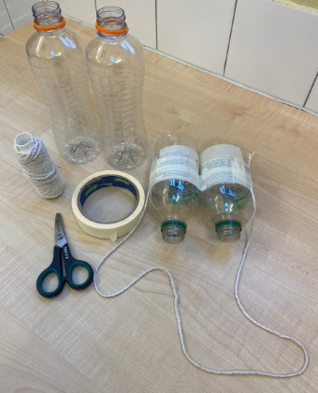
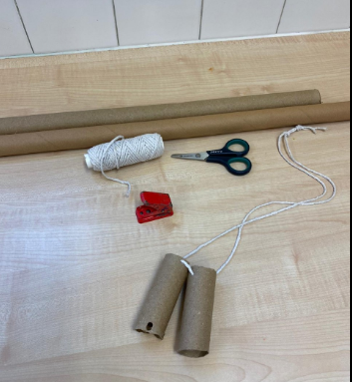

Story
Here is a link to a lovely story all about a little robin. Get cosy and enjoy!

BBC iPlayer - CBeebies Bedtime Stories - 729. Idina Menzel - Robins Winter Song

Self-help
Are you ready for another go at your ‘LUCKY DIP’ game?
Remember, there is still time to print off the pictures from yesterday (but don’t worry if you can’t, you can draw them instead), fold each picture up and put them all into a box. Then each morning when you get up, give the box a shake, open it, pick out a picture and do that special job! You might even think of some other things to add in if you’re feeling extra helpful! I have thought of some more…..How about using a dustpan and brush to sweep up or maybe sorting your toys into the correct toy boxes etc! I’m sure your grown up would love that!

Gross Motor

We are so excited that its yoga time again! It always makes us feel so calm and peaceful.
Mrs Barnard has made us a new video. Follow the link to our website Welcome to Newburn Manor Nursery School (newburnmanor-nur.newcastle.sch.uk) or visit our Facebook pages. It includes some new Yoga poses. Fantastic! All of the new poses are animal themed and I bet you can recognise some of them from when we were learning about lots of different animals last week!

Here are some of the poses below… a crocodile pose, a lion pose and a frog pose. Can you practice some of them before watching the video?

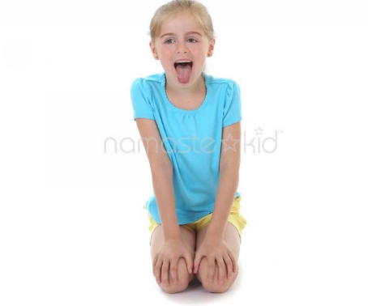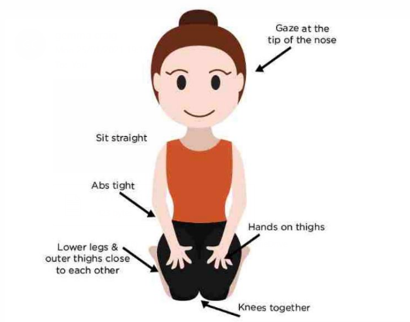

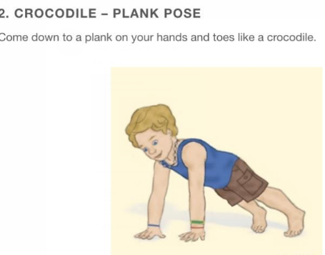
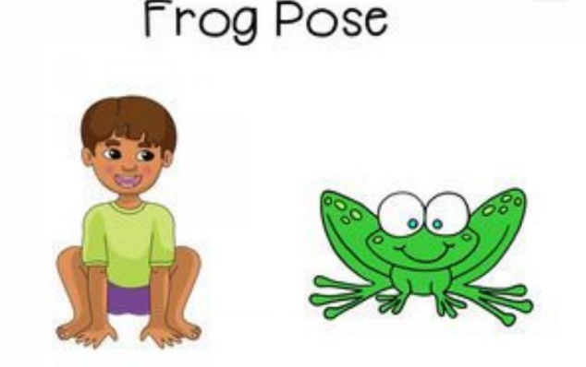

Fine Motor/ Song time
Song box time! Watch Mrs Barnard sing a new song to us. Follow the link to our website Welcome to Newburn Manor Nursery School (newburnmanor-nur.newcastle.sch.uk) or visit our Facebook pages. Today’s song is Round and Round the Garden! I wonder if you have a little teddy bear that can help you sing?
Finger play songs are so helpful in developing fine motor skills. They are also good for increasing vocabulary, learning the sounds of word and hearing the rhythm of language. If your child is very familiar with the song, you could challenge them and have fun by experimenting and changing up some of the words to make your own version of the song!

Examples are:

Round and round the garden like a Dinosaur…1 stomp, 2 stomps, 3 stomps, ROAR!

Round and round the bedroom like a teddy bear, 1 hop, 2 hops, tickly under there!

You can be as silly as you like and the songs don’t have to rhyme (although emphasising and pointing out any rhyming words would be a great idea)
Have fun!!!

Maths
This is a fun maths game and all you need is some blocks OR Duplo OR Lego AND a dice! A grown up could also write the numbers 1-10 in order, on a bit of paper (to make a number line). This would be very helpful!
This is a two player game. Roll the dice and work out what number the dots are representing. Now build a tower with that same number of blocks. The second player does the same and whoever has the tallest tower (the MOST blocks) scores a point. Make sure to use language such as “more, less and fewer”
Whilst playing the game you could use the number line to help identify the numerals and to also work out which number is the biggest and which is the smallest.
Play as many times as you like! Whoever scores the most points wins.
To extend you could use 2 DICE. Add both numbers together by counting the dots on both. Remember, though, that your number line will have to go up to 12!

