REMOTE LEARNING DAY 9
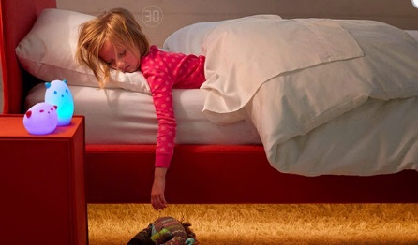
This Photo by Unknown Author is licensed under CC BY-SA-NC
Self-help
Make your own bed
I wonder if you can make your own bed without your grown up’s help?

Fine motor / muscle stamina
Make snowflakes
Let’s see how you’re getting on with using scissors! Have you been practising? I bet you’re doing a super job!
All you need is some white paper and scissors! First fold a piece of paper, then fold again and again until your piece of paper is smaller than when you started! Next start tearing, snipping or cutting. Finally carefully open up your paper and ta dah……..you’ve made a sparkling snowflake!

Gross motor
Musical statues
Play your favourite music and dance, dance, dance ……… BUT remember to stop dancing when the music stops! So you’ll need to have your listening ears switched on!

Song Time
Song box time
Time to sing some of your favourite songs from your song box! Remember to sing the song to open the box first…….
“What’s in the box, what could it be, shall we see?”

Challenge time!

Can you make a home for your pet or your sock puppet?
If you haven’t got a pet or didn’t make a sock puppet then don’t worry, you can always make a home for one of your teddies instead.
You will need some old boxes, scissors, glue, sellotape. We would love to see what you’ve made! Here are some of the pet homes we’ve been busy making ………
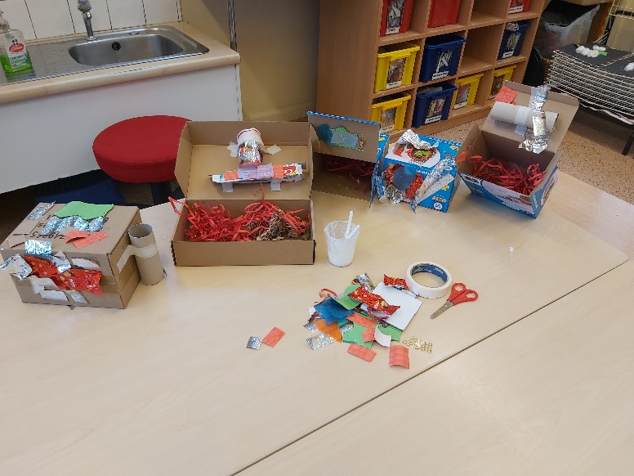
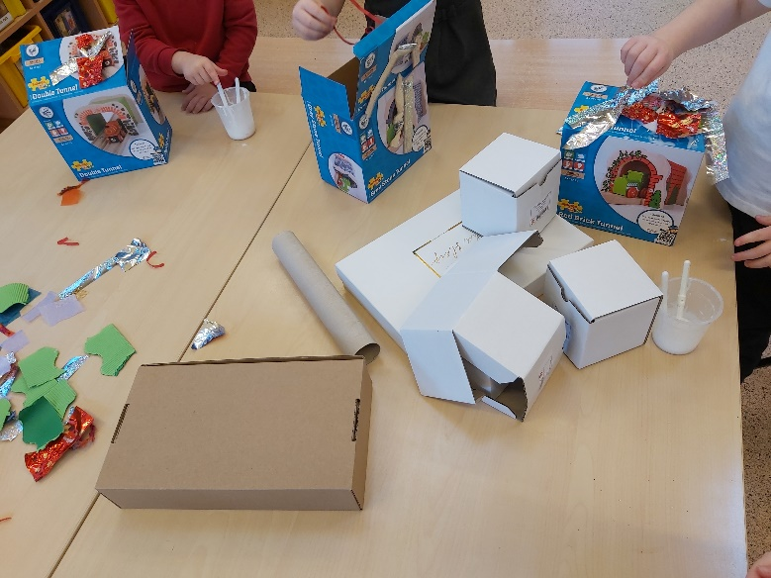
…………. homes for a hamster, a dog and even a snake!!!!

If you’d like another challenge then try searching on your iPad with your grown up for facts about your pet……
Mrs Young looked on her computer and found out 3 facts about her hamsters, Isla and Lola:
- Hamsters are nocturnal (this means they are awake at night and sleep during the day).
- Hamsters will run 5.6 miles each night on its wheel (that’s even further than your journey to nursery!).
- Hamsters store their food in pouches in their cheeks.
- Hamsters live in cages.
