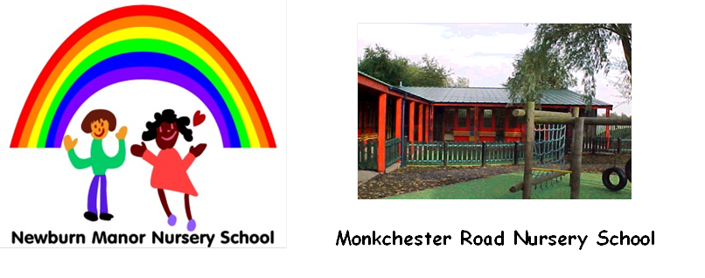


Ashfield Nursery School

Newcastle Nursery Schools’ Federation
Admissions Policy
To be reviewed Annually – Spring 2026

PURPOSE
This policy sets out how the Nursery Schools in the Federation will fulfil their responsibilities regarding the admission of pupils.
Newcastle Nursery Schools’ Federation consists of three Nursery Schools, Ashfield, Monkchester Road and Newburn Manor.
The Governing Body are the admission authority and are responsible for setting the school’s Nursery Admissions Policy.
Three and Four Year Olds
All three and four year olds in England can get 570 hours of free early education as a universal entitlement, this is often taken as 15 hours a week for 38 weeks of the year.
Some working families are entitled to 30 hours extended entitlement. Criteria can be found online or shared by office staff in each Nursery.
Two Year olds.
All two year olds that meet the eligibility criteria for the two year old offer can access a free learning place of 15 hours a week. Eligibility Criteria can be found online or shared by office staff in each Nursery. Two year olds who are not eligible for the two year old offer can pay for a place if there is room available in the playgroup.
Some working families of 2 year olds can get 30 hours extended entitlement from September 2025. Criteria can be found online, or information can be given from office staff.
Application Process for Three/ Four Year Olds and Two year Olds
Waiting List
Parents can register their interest for a place at each nursery or playgroup anytime following their child’s birth. An application form needs to be filled in, and the child’s birth certificate shown to staff in the school office.
These children will be entered on a waiting list to be considered for a place when they reach the appropriate age. Placing a child’s name on the waiting list does not guarantee that a place will become available for the child.
Offering Places
The main point of entry into Nursery will be September every year. Places for Nursery will be offered in the Summer Term initially, by contacting parents by letter, telephone or in person using the contact details provided. If there are additional spaces available in Nursery over the year, then these will be offered to children.
Places for Playgroup will be offered if there is a place available after the child turns two.

Attendance at a Nursery School does not guarantee a place in a Reception Class.
If there are more children on the waiting list than places available, then priority will be given by the Governors in line with the oversubscription criteria.
Oversubscription Criteria
Places will be offered to children who have an Education Health Care Plan where the plan names a specific school.
- Looked after children (LAC) in the care of a local authority or children that were looked after and then became subject to adoption, residence or special guardianship order. Evidence of the appropriate order must be submitted.
- Children who are on the Child Protection Register and live in the area served by the school.
- Children with additional needs
- Children with a sibling currently in the nursery school or playgroup.
- Distance from home to the Nursery School
If there are more places within a category, then places will be allocated in date of birth order starting with the oldest child.
If all children meet the criteria, then the place will be given based on when the child was added to the waiting list.
Nursery Schools in the Federation who have had to refuse a place because there are more applications than places available will keep a waiting list of the names of applicants. If a place becomes available, it will be offered to the applicant on the waiting list who ranks highest in accordance with the published admission policy.
There is no appeal procedure for parents refused a place in a nursery school.
Parental Responsibility
Parents who share responsibility for the care of their child are expected to reach agreement to a nursery placement between them. In the event of a dispute the school will accept the application from the parent who receives, or is eligible for, the payment of the child benefit.

In Year Intake
If space is available, we will admit children the term before they are three throughout the year. Children may also move up from playgroup after they have turned three.
Parents who have submitted applications for their children for the following September will be contacted by letter offering their child to start earlier.
Charged Sessions
All families can buy additional sessions in nursery/playgroup if there is room. In playgroup parents can buy additional sessions on top of their 15 hours. If more demand for bought sessions than places, then the oversubscription criteria will be used again.
Further information for parents about submitting an application form or finding out if they are eligible for the 2 year offer or 30 hours should contact the school office at each Nursery.
Ashfield Nursery School – 0191 273 5587 or email admin@ashfield.newcastle.sch.uk
Monkchester Road Nursery School – 01912654579 or email admin@monkchesterroad.newcastle.sch.uk
Newburn Manor Nursery School – 01912774180 or email admin@newburnmanor-nur.newcastle.sch.uk

