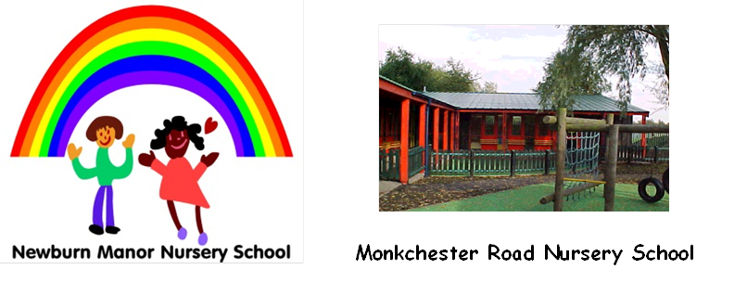



**Ashfield Nursery School**

**Newcastle Nursery Schools’ Federation**

**Equality Policy**

**2024-25**

Ratified by Governors 26/3/2025

Review Date_________________________

**Statement of Intent:**

Our Federation is committed to anti-discriminatory practice for all children and families. We respect and value the diversity which exists in the wider community. We are committed to challenging attitudes that promote discrimination, ensuring respect for all and preparing all children for life in a diverse society.

Our Federation will not tolerate discrimination, harassment, bullying, victimisation or abuse of members of staff or any people using our service.

**We aim to:**

* Ensure that all children and adults are encouraged and able to achieve their full potential.
* Respect and value differences between people.
* Prepare children for life in a diverse society.
* Acknowledge the existence of prejudice and take steps to prevent it.
* Make our environment a place where everyone feels welcomed and valued.
* Improve our knowledge and understanding of beliefs, cultures and disabilities.
* Access staff training when the opportunities arise.
* Challenge any offensive behaviour, language or attitudes with regard to race, ethnicity, nationality, class, religion, culture, language, sexual orientation and disability.

**The legal framework for this policy is:**

* The Equalities Act 2010 (which came into force 2011)
* Sex discrimination Act 1975
* Disability Discrimination Act 1995
* Human Rights Act 1998
* Race Relations Amendment Act 2000
* UN Convention on the Rights of the Child -1989
* Children Act 1989, 2004
* Special Educational Needs and Disability Act 2001
* Public Sector Equality Duties 2010

This Legislation is used to provide protection against discrimination for people who share the following protected characteristics:

* Age
* Disability
* Gender reassignment
* Marriage and civil partnership
* Pregnancy and maternity
* Race
* Religion and belief
* Sex
* Sexual Orientation

**Admissions:**

Our Federation is open to all members of the community:

* We welcome all families equally.
* We advertise our service in the community and support all families with protected characteristics.
* We reflect the diversity of members of our society in our publicity and promotional materials.
* We provide information in clear, concise language, whether in spoken or written form.
* Where possible we provide information in languages of our community.
* We do not discriminate against any children, parents or carers on any grounds.
* We ensure that all parents and carers are made aware of our equalities policy.

**Employment:**

* We are an equal opportunity employer; posts are advertised and all participants are judged against explicit and fair criteria.
* All job descriptions include a commitment to equality and diversity as part of their specifications.

**Training:**

* We seek out training opportunities for staff and volunteers to enable them to develop practices which enable all children to flourish.
* We review our practices to ensure that we are fully implementing our equalities policy.
* We ensure that all staff have an understanding and knowledge of equality

and diversity, and the characteristics of protected groups.

**General:**

* Every member of staff is responsible for equality
* We encourage parents to share skills with staff and children.
* We handle questions about difference honestly, sensitively and openly (age appropriate)

.

* We treat everyone with respect and with consideration of their diversity.
* We provide a welcoming atmosphere with approachable staff.
* We offer children a secure environment in which to explore their own culture and that of their peers.
* We actively seek ways to counter the learning of negative attitudes and behaviour towards differences.
* We check that our resources reflect diversity and equality and do not promote negative stereotypes.

**Equality Procedures**

**Working with parents/carers:**

Federation staff will work in close partnership with parents/carers to ensure that all children’s needs are supported with regard to their developmental progress.

* Regular observations and assessments will be made on all children to assist staff in planning to meet a child’s individual needs and interests.
* We will facilitate regular opportunities for consultation with parents/carers about the service as a means of monitoring the effectiveness of inclusive practice, as detailed in the Equality Policy.
* Staff will work in partnership with parents/carers to ensure that medical, cultural and dietary needs of children are me.

**Staffing:**

* Staff are recruited in line with Newcastle City Council’s equal opportunities policies.
* Newcastle City Council’s Grievance and Disciplinary policies will be used to deal with any complaints about discrimination, harassment or bullying involving staff.

**Working with children:**

* Staff are committed to displaying themselves as positive role models for children and will encourage children to value and respect others through everyday routines, imaginary play and activities that promote non-stereotypical images.

* Staff will ensure that sanctions used in the nursery are the same for boys and girls and are applied equally.
* We will have regard for promoting understanding, respect and awareness of diversity and equal opportunities in planning and implementing our programmes of activities.
* We will help all children to celebrate and express their cultural and religious identity by providing a wide range of appropriate resources and activities.

**Monitoring and Reviewing:**

The Head Teachers will be responsible for ensuring that the Equality Policy and Procedures are implemented and that their effectiveness is regularly monitored. To ensure that these policies remain up to date, they will be reviewed annually.

They will also be responsible for ensuring that:

* Staff receive appropriate training
* The Equality Policy and Procedures are consistent with current legislation and guidance.
* Appropriate action is taken wherever discriminatory behaviour, language or attitudes become apparent.

If the inappropriate behaviour is from a child:

* The child displaying the behaviour will be removed from the situation and spoken to, at their level of understanding, by a member of staff and have explained to them why what they have said or done is “unkind” and not acceptable in the nursery.
* The child who has been subjected to discrimination/bullying will be comforted by a number of staff.
* The parents/carers of both children will be spoken to when collecting the children.

If the inappropriate behaviour is from a member of staff, Newcastle City Council’s discrimination procedure will be followed.

**Resources**

We ensure that our resources in each school reflect the society we live in and we will ensure children are aware of our similarities and differences and respect those.

Each school is building up a collection of books to reflect children and the society we live in.

Examples include:

|  |  |  |
| --- | --- | --- |
| **Book Title** | **Author** | **Area covered** |
| We all Belong | Nathalie Goss | Diversity, race, differences and similarities in clultures |
| The Great Big Book of Families | Mary Hoffman  Ros Asquith | Different families |
| People Need People | Benjamin Zephaniah | Connecting with others, being kind to each other |
| Dim Sum for Everyone | Grace Lin | A Chinese American family and a dim sum meal |
| For Every Child | Various | The rights of a child |
| Susan Laughs | Jeanne Willis | Susan is in a wheelchair but does everything like everyone else |
| The Proudest Blue | Ibtihaj Muhammad | Religion and identity and wearing a hijab |
| Julian is a Mermaid | Jessica Love | Acceptance of a boy and how he sees himself |
| Happy in our skin | Fran Manushkin | New babies and a celebration of different coloured skin. |
| My world, your world | Melanie Walsh | Similarities and differences of people |
| It’s a No Money Day | Kate Milner | Using a food bank |
| My name is not refugee | Kate Milner | The journey a boy and his mother make |
| The Can Caravan | Richard O’Neil | Traveller values |
| Jill and the Beanstalk |  | Re working of fairy tales |
| Home | Carson Ellis | Different types of homes |
| What happened to you? | James Catchpole | Disability |
| Mama Car | Lucy Catchpole | Parent in a wheelchair |
| Amazing | Steve Antony | Celebrating diversity |
| Daddy, Papa and me | Leslea Newman | Same sex parents |
| Mommy, Mama and Me | Leslea Newman | Same sex parents |
| Lubna and the Pebble | Wendy Meddour | Friendship, refugee crisis |
| Hair Love | Matthew A Cherry | Dad doing child’s hair, Mum at work |
| Grandad’s Camper | Harry Woodgate | Grief, two Grandads |