REMOTE LEARNING - Wednesday 27th January

Good morning everyone! Happy Wednesday! I wonder how our little bird watchers are getting on? Today we’d love you to count the birds that come into your garden. In nursery we love to record by drawing tallies! Sometimes we draw tallies to show how many boys and girls are in the class that day or how many people choose apple/banana/orange from the fruit bowl etc. It is a great way to represent numbers. We also try very hard at writing the numeral too! Do you think you could have a go at drawing tallies and numbers to show how many birds visit your garden today? You could even make a line of tallies for the different types of birds that visit!

Here are some tallies that Mrs Howell has drawn. Can you see how many robins and magpies visited? Did more magpies visit, or more robins?

*Birds to look out for when bird watching*
https://www.rspb.org.uk/fun-and-learning/for-teachers/schools-birdwatch/birds-to-look-out-for/

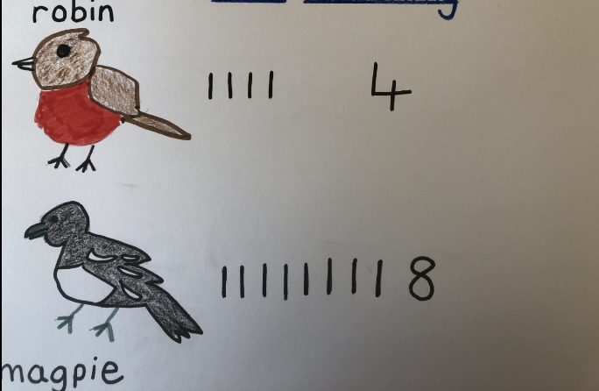

Story
Here is a link to a lovely story all about birds read by Ore Oduba
A Busy Day for Birds read by Ore Oduba - Bing video

Self-help
Are you ready for another go at your ‘LUCKY DIP’ game?
Remember, there is still time to print off the pictures from Monday (but don’t worry if you can’t, you can draw them instead), fold each picture up and put them all into a box. Then each morning when you get up, give the box a shake, open it, pick out a picture and do that special job! You might even think of some other things to add in if you’re feeling extra helpful! Yesterday I thought of these….. using a dustpan and brush to sweep up or maybe sorting your toys into the correct toy boxes etc! Today I thought of another one….putting on your gloves! It’s a bit tricky making sure each of your fingers are in the right place. It takes a bit of practice.

Gross Motor

Miss Ritzema is going to show us another Write Dance song today, follow the link to our website Welcome to Newburn Manor Nursery School (newburnmanor-nur.newcastle.sch.uk) or visit our Facebook pages. We love drawing patterns and practicing our pencil grip whilst singing and moving to music! The song we are going to be making marks to today is….Incy Wincy Spider!!! Lying on your tummy and drawing on old rolls of wallpaper or card board is perfect for this job but, of course, sitting at a table does the job too!
Why not have a go at drawing a spider afterwards? How many legs will it need? Of course you’ll then need to write your name on your drawings so everyone will know it belongs to you! Maybe your grown up will help you with your letter formations.

Fine Motor/ Song time
Song box time! Finger play songs are so helpful in developing fine motor skills. They are also good for increasing vocabulary, learning the sounds of word and hearing the rhythm of language. Watch Mrs Barnard sing a new song to us, follow the link to our website Welcome to Newburn Manor Nursery School (newburnmanor-nur.newcastle.sch.uk) or visit our Facebook pages. Today’s song is Little Mousey Brown and it’s all about a little mouse.

You could have a go at making your own mouse finger puppet to help you sing the song and join in with the actions. Follow the link for a tutorial (or you might have ideas of your own)

How to make a Paper Mouse Finger Puppet - or R is for Rat! - Red Ted Art - Make crafting with kids easy & fun

Have a lovely day!

Tomorrow we will be making playdough (with a special ingredient….ginger)
You will need: plain flour, cream of tartar, cooking oil, ginger (and cinnamon-optional), lots of salt

