**Newcastle Nursery Schools’ Federation**



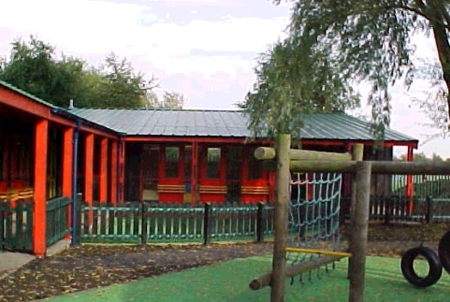

**Monkchester Road Nursery School**

**Ashfield Nursery School and Al2gether @ Ashfield**

**Newcastle Nursery School Federation: PLAYGROUP MANAGER**

The governors of Newcastle Nursery Schools’ Federation are seeking to appoint a Playgroup Manager to lead one of our busy Playgroups – as soon as possible.

This post will be mainly based at **Ashfield Nursery School** (in the first instance)

Wednesday (12.15 to 4.15 p.m.), Thursday and Friday (8.00 to 4.00 p.m.)

Total hours: 19 hours per week

Fixed Term 1st June 2025 until August 2025 initially - with opportunity to extend this into the new academic year 25-26 for the successful candidate.

Grade N6

Salary £31586 to £34314 per annum (Actual salary £13,600 to £14,774 per annum)

We are looking for someone who:

* Is an imaginative, creative practitioner, keen to provide the very best curriculum to inspire and motivate all of our children
* Is committed to providing a safe and inclusive environment for all children and staff.
* Has an endless curiosity about early years’ education and a thirst for continual professional development to further develop education provision for 2 year olds.
* Has a level 3 qualification (or above)
* Has at least two years’ experience working in a playgroup setting, preferably as a leader/manager.
* Has a positive and enthusiastic approach and works flexibly within teams
* Has a skill set that will complement those that currently exist in school.

The Playgroup manager has their own key group of children and manages the day to day work of all staff in the Playgroup, including planning and assessment.

You will be expected to ensure policies, practices and procedures are followed in the unit. Excellent communication with children, parents and staff is an essential part of the role.

Our Federation is fully committed to safeguarding children and applicants are required to complete several pre-employment checks and other activities to ensure they are safe and suitable to work with our young children. Our safer recruitment procedures include (but are not limited to) DBS checks and the taking up of two references before the interview process commences. One reference must be from the candidate’s current employer.

The role advertised here is based at Ashfield Nursery School, in the first instance, but you would be part of the Federation and your contract would be to work in any of the settings when requested.

Visits to Ashfield Nursery School can be arranged by appointment prior to interview – please phone Kay Mills (0191 2774180) or Anne Humble (0191 2654579)

If you are interested in this position please download an application pack from our Federation Websites – [www.ashfield.newcastle.sch.uk](http://www.ashfield.newcastle.sch.uk), [www.monkchesterroad.newcastle.sch.uk](http://www.monkchesterroad.newcastle.sch.uk), or [www.newburnmanor-nur.newcastle.sch.uk](http://www.newburnmanor-nur.newcastle.sch.uk)

Once completed, candidates should post their application forms and include a letter of application, stating how they meet the person specification provided. These documents should be returned to **Jacqui Hamilton at Ashfield Nursery School, Elswick Road, Newcastle upon Tyne NE4 6JR** by 12.00 Noon on Friday 16th May 2025

Alternatively, candidates may deliver their applications to one of our schools by hand.

**PLEASE NOTE WE DO NOT ACCEPT ANY EMAIL APPLICATIONS.**

Closing Date: Friday 16th May 2025 Noon

Observations of teaching and interviews will be held w/b 19th May 2025