**Newcastle Nursery Schools’ Federation**



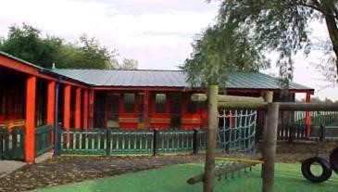

**Monkchester Road Nursery**

**Ashfield Nursery School and**

**Al2gether @ Ashfield**

**Governing Body Statement of Behaviour Principles**

*Section 88(2) of the Education and Inspections Act 2006 requires the governing body to:*

1. *make, and from time to time review, a written statement of general principles to guide the headteacher in determining measures to promote good behaviour and discipline amongst children; and*
2. *notify the headteacher and give her related guidance if the governing body wants the school’s behaviour policy to include particular measures or address particular issues.*

*This statement is to be read in conjunction with the school behaviour policy, which is reviewed and approved every three years by the governing body.*

Our principles are that:

* + Staff and children will be polite and respectful at all times, to each other, to parents, visitors and the wider school community.
  + Any form of discrimination or bullying will be addressed promptly (including discrimination and bullying linked to ability, additional educational need or disability, age, culture, faith, gender, ethnicity or sexual orientation)
  + Staff and the governing body will provide opportunities for children to develop selfregulation, self-control and self-discipline at age/stage appropriate levels. They will encourage in children a sense of responsibility for the school and its environment and ensure children are involved in sharing their views and making decisions.
  + Staff will be fair and consistent and foster a culture in which children’s achievements are recognised and celebrated by ensuring that they use praise, encouragement and rewards effectively. These attributes are used to promote learning and success and secure good staff – child relationships.
  + Expectations for behaviour and learning will be explicit and consistent to ensure that children understand the consequences, including what to expect if they breach the rules hurt others or disrupt learning. Staff will ensure that children are aware of any sanctions and apply these in a fair and consistent manner.
  + Staff will be empowered to take prompt and effective action when children behave inappropriately. Senior leaders will provide support for staff via training, supervision, mentoring and staff meetings. Staff are encouraged to share and discuss any behavioural concerns with senior leaders in a supportive environment that fosters joint problem solving.
  + To ensure effective management of teaching and learning, classes are well – organised with lessons that are stimulating, appropriate and differentiated.
  + The school will work in partnership with home and external agencies to promote these behaviour principles thereby maximise the chances that every pupil learns to behave responsibly.

1

Working in partnership also means that Parents will:

* + behave in a respectful and polite manner towards children, staff and each other by

* 1. not using mobile phones on school premises
  2. not smoking (including the use of e-cigarettes) whilst on school property
  3. not swearing or using inappropriate language
  4. not bringing dogs into the school grounds

Written: October 2019

Reviewed by Governors: October 2022

Next review: October 2023

2