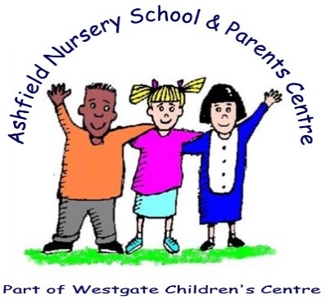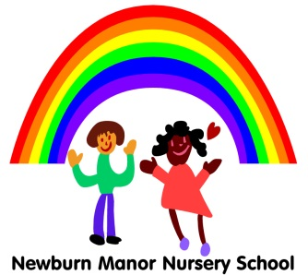

Dear Parents and Carers,

We hope you have had a good Christmas and enjoyed the break.

As you may know from the news, many unions have told staff in schools **NOT** to return to work **IF** schools are open to **ALL** children.

While the Government state that it is safe enough for children in ***most*** Primaries and Nurseries to return to school this week, staff unions advise that schools should ***only*** open for the children of keyworkers and for vulnerable children. Unions advise this should be for the first two weeks in January.

We have spoken to staff at Newburn Manor Nursery School and Playgroup and they prefer to follow their unions’ advice. This advice is to open for keyworkers’ children and vulnerable children only. Unions hope this will limit the spread of the virus and keep our children and staff safest over the next two weeks.

As such, Newburn Manor Nursery School and Playgroup will only open for vulnerable children and the children of keyworkers from Tuesday 5th January 2021 until 20th January 2021.

A list of jobs that are ‘keyworkers’ or ‘critical workers’ is attached here* and is available at <https://www.gov.uk/government/publications/coronavirus-covid-19-maintaining-educational-provision/guidance-for-schools-colleges-and-local-authorities-on-maintaining-educational-provision>

We will be available on Monday to take your calls and answer any of your questions by phone or email, but only the children of keyworkers or those who are vulnerable should come in to Nursery/Playgroup on Tuesday 5th January 2021.

Please call us today or email Nursery/Playgroup if you are not sure if your child can attend on Tuesday and we will be happy to explain this in person.

If your child cannot come in to Nursery/Playgroup, we will be posting ‘remote learning’ on to our Facebook and Website pages to give ideas for things to do at home with your child. We will also update you soon on how to access Free School Meals if your children qualify for these but will not be in school.

We apologise for the late notice of this change to our procedures, but we have been waiting for government guidance and union advice before making our decisions.

We are committed to providing the best education we can, face-to-face with children ***as soon as this is safe enough*** for all of our children and staff. When unions advise staff to return to work for **ALL** children, we will be in touch with you to let you know when **ALL** children can come back to Nursery.

Thank you for your understanding with this difficult decision. Please contact Nursery on 0191 2774180 or by email: [jenna.stephenson@newburnmanor-nur.newcastle.sch.uk](mailto:jenna.stephenson@newburnmanor-nur.newcastle.sch.uk) [admin@newburnmanor-nur.newcastle.sch.uk](mailto:admin@newburnmanor-nur.newcastle.sch.uk) If we can help you with anything further.

Mrs. Mills and all of the Staff at Newburn Manor Nursery and Playgroup

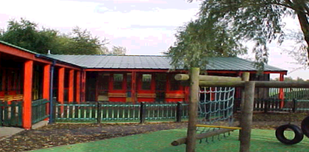

**Monkchester Road Nursery School and Playgroup**

**Ashfield Nursery School and Al2gether @ Ashfield**

**Newcastle Nursery Schools’ Federation**