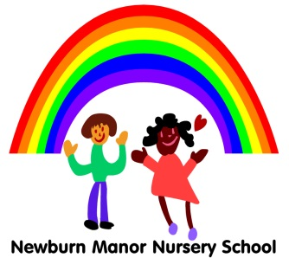
Newburn Manor Nursery School
Pupil Premium 2016/2017

This academic year (2016/17) the Nursery will receive a total of £3107
Currently the money has been spent on:
- Early Talk Boost training, resources and staff to run the group accessed by some Pupil Premium children (summer 2016)
- Resources to support communication and language development – café set, magnetic letters, Velcro board.
- Some hours of a member of staff to support and target pupil premium individuals with their overall development and learning.
- Writing resources ie boogie boards as writing was identified as an area for development in the end of Autumn term data (Dec 16)

Update
The highest area of progress for this group in December was in the area of Communication and Language (Dec 16)
Update July 2017
- The large majority of this group are at age related expectations at the end of the year in all seven areas.
- The large majority of this group has made at or above typical progress in all aspects this year.

AOL SUMMARY Pupil Premium 2016 17 Attainment
 |  | Baseline |  |  | Autumn |  |  | Spring |  |  | Summer
Aspects | Below | At | Above | Below | At | Above | Below | At | Above | Below | At | Above
PSE | 55.6% | 44.4% |  | 38.9% | 61.1% |  | 50.0% | 50.0% |  | 5.6% | 94.4%
CL | 61.1% | 38.9% |  | 38.9% | 61.1% |  | 22.2% | 77.8% |  | 11.1% | 88.9%
PD | 33.3% | 66.7% |  | 16.7% | 83.3% |  | 8.3% | 91.7% |  | 16.7% | 83.3%
LIT | 58.3% | 41.7% |  | 50.0% | 50.0% |  | 33.3% | 66.7% |  | 25.0% | 75.0%
MATHS | 66.7% | 33.3% |  | 25.0% | 75.0% |  | 16.7% | 83.3% |  | 33.3% | 66.7%
UW | 61.1% | 38.9% |  | 33.3% | 66.7% |  | 22.2% | 77.8% |  | 16.7% | 83.3%
EAD | 41.7% | 58.3% |  | 8.3% | 91.7% |  | 8.3% | 91.7% |  | 8.3% | 91.7%

