REMOTE LEARNING – Monday 1st February

Good morning everyone! It’s Friday!!! Well done for getting to the end of another week and doing the best you can. You are all brilliant!
We are rounding off Bird Watching week with the story ‘Owl Babies’ read by Mrs Barnard, unfortunately we had to do it two parts (See Facebook or Welcome to Newburn Manor Nursery School (newburnmanor-nur.newcastle.sch.uk)) It is a firm favourite in nursery so I’m sure you’ll all help read along!

I bet you didn’t see any owls when you were bird watching! I didn’t either! Does anyone know why? Owls are nocturnal! That’s an unusual word isn’t it? I wonder if anyone knows what it means? It means they sleep through the day and wake up at night. We don’t see owls flying around because we’re all fast asleep and tucked up in bed when they’re awake! Today you could use books, an ipad, laptop or a phone to find out about some other nocturnal animals!

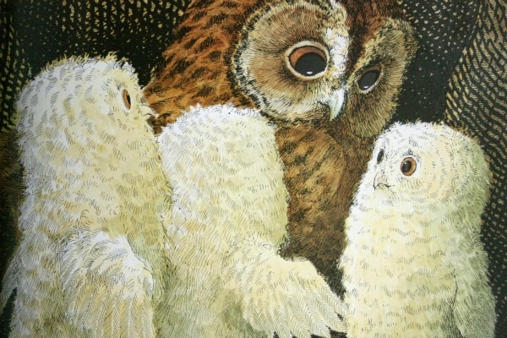

Mrs Stephenson has a lovely owl puppet she’d like you to meet! She is going to sing a fun action song with the owl and we hope you join in! (see Facebook or Welcome to Newburn Manor Nursery School (newburnmanor-nur.newcastle.sch.uk))

Self-help
It’s the last day of our ‘LUCKY DIP’ game (see Monday’s Remote Learning sheet for a reminder of what the game is)
You are all superstars!!!!! Remember to keep practicing the skills that you found particularly tricky!

Fine Motor/ Song time
It’s Song box time again! Watch Mrs Barnard sing a new song to us (the last one from our Finger Play song box) (see the video on Welcome to Newburn Manor Nursery School (newburnmanor-nur.newcastle.sch.uk) or Facebook). Today’s song is ‘Tommy Thumb’. You may have started to make your own ‘Finger Play song box’. I think a great prop for this song, to go in your box, would be a pair of gloves!!

Gross Motor
Spell out your full name and complete the activity for each letter. Challenge yourself by doing your surname too! If you want to you can try and complete activities for the names of your family members or friends!

Not only is this great exercise…it’s also a great activity for letter, numeral recognition and counting too! Have a go at writing your name first to work out what your exercises will be!

Ready, steady, go!!!!

a | Hop on one foot 10 times | n | March like a soldier for the count of 15
b | Jog on the spot | o | Run on the spot
c | Bend and touch your toes 5 times | p | Wibble like jelly
d | Skip around the room | q | Do 10 push ups
e | Do 8 star jumps | r | High knees
f | Trot around the room like a horse | s | Flap like a bird 20 times
g | Waddle like a penguin | t | Jump up and then touch your toes 5 times
h | Slither like a snake | u | Do 8 sit ups
i | Do 7 frog jumps | v | Pretend to skip with a skipping rope
j | Spin around in a circle 6 times | w | Kick for feet
k | Jump as high as you can 10 times | x | Crawl around the room
l | Leap like a leopard 10 times | y | Jump up and grab 20 clouds
m | Balance on your left foot and count to 10 | z | Dance

Time for a sit down after our exercise I think! Let’ make some owl hand prints using paint OR you could draw around your hands if you don’t want to use paint!

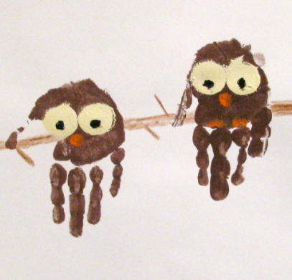

Enjoy your day and have a great weekend!

