REMOTE LEARNING Thursday 22nd Jan (DAY 12)

Self-help
How are you all getting on with getting dressed by yourselves? We hope you have been helping your grownups! ~ Our job today is something lots of you find a bit tricky… Pulling up your pants/knickers and trousers.
Remember, when you are getting dressed/or have been to the toilet, you need to pull up your underwear first (or you will get in a pickle! ) Put your hands on the top of your pants/knickers and pull them up over your bottom. You may need to give a little wiggle to make sure they are pulled right up. Once you have done that, put your hands at the top of your trousers/tights and then pull them up over your bottom. You may be wearing joggers at home which are easier to pull on. Try practising with your school trousers/skirts too, so that you don’t forget how to do it when you come back to Nursery. You may have a clasp/button and zip at the top of your trousers/skirt. Have a go and see if you can do these too. We know how good you are with your zip on your coats, so have a go! Is it tricky? Keep practising at home. Your grownups will be super proud of you for trying to help. We are all proud of you too!
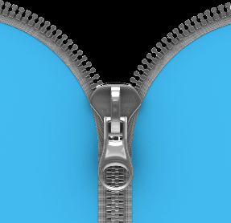
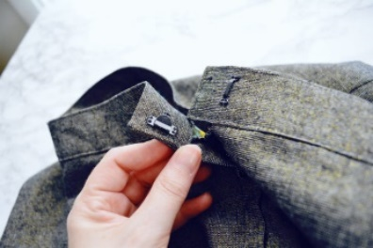

Gross motor/Song time
Are you ready for some exercise? Today we are going to do the Animal Boogie!! ~ In this story there are lots of different animals. Open this link to watch the story and join in with the actions. Can you move your bodies in different ways like the animals in the story? We’d love to see some photos of you joining in. https://www.youtube.com/watch?v=25_u1GzruQM
Can you guess where these animals would live? Maybe in the jungle or on a farm? I wonder if you would like any of them as a pet… maybe an elephant?
I bet you need a rest now from all of that boogying. What happens to your bodies when we exercise? That’s right… you feel tired, you might be hot, thirsty and you might be breathing a bit quicker. We need to exercise to stay nice and healthy.

Fine motor/Muscle Stamina
You’ve worked so hard today, I think it is time for a nice calming activity! ~ We have been thinking about what we might have at home, that we could use, to make lots of different marks/drawings and patterns. At Nursery, we found a tray and decided to put some glittery sand on it. We then chose to use our finger to make different patterns and shapes. It was so much fun!
Nursery have come up with a big list of lovely things that you might be able to find in your home (flour, sugar, salt, sand, breadcrumbs, rice, soil, glitter, herbs & spices, cocoa powder).
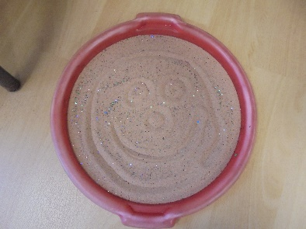
You could use an old tray, or tablecloth, or maybe even do it outside. Its completely up to you!

