REMOTE LEARNING Wednesday 20th Jan (DAY 11)

Self-help/ Fine motor/Muscle Stamina
Did you manage to match all of your socks yesterday? … well done!! ~ I think you might be ready for today’s challenge!
I know we have already practised this job at home but I wonder if you can remember how to do it…
Without any help today, can you show your grownups how clever you are at putting on your socks and shoes? Remember to put your toes inside your sock first, before you pull it on. Don’t worry if they are inside out or the wrong way around, just getting them on your feet is fantastic! Once your socks are on, can you try and put your shoes on? Your shoes may have buckles on them today. I wonder if you can have a try at doing them up. It’s a bit tricky! Once you have put them on, see if you can surprise your grownups again by taking them back off! Maybe you’ve got laces on your shoes today, see if you can untie them without getting in a tangle!

Gross motor
Now, for our job today you will need those little toes out! ~ We know how much you all love this job at Nursery, so we thought today we could do some Yoga! You don’t need much for this activity. Maybe your grownup has a mat you could borrow, but don’t worry if not, you don’t need to use one. We know it might be tricky, but can you find a nice quiet space in your home where you can join in with Mrs Barnard? See how many of the poses you can remember. The yoga poses are on the next page, to help your grownups join in with you. Visit our Facebook pages for the video which is scheduled for release at 8:30am Wednesday 20th January 2021.

Song Time
Are you feeling all relaxed after Yoga? ~ I thought we could sing a song to wake us bit a bit. Im thinking of a song with lots of animals in… but these animals might not be pets in your house… These animals may live on a farm. Can you guess which song it is? YES, that’s right… Old MacDonald had a farm!
Here is a link to help you learn the song https://www.youtube.com/watch?v=FQJIoN0bJOg
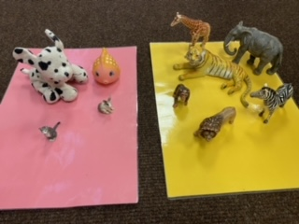
I wonder if you have got any toy animals (cuddly toys, plastic toys, photos of animals) in your home. Don’t worry if you haven’t, but if you have can you sort them into groups? Which animals live on a farm/zoo/jungle? Which animals would make good pets? We have had a try at Nursery. Have a look at the pictures below, can you spot which animals live in the zoo and which animals would make good pets? Is there anything that looks similar (same number of legs) or anything that looks different? Have a chat about what you have noticed with your grownups.
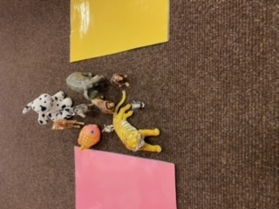

Yoga Poses
