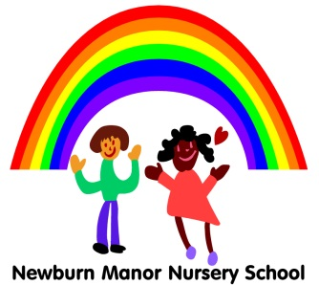
Newburn Manor Nursery School
Understanding the World Policy April 2017
Review April 2018

RATIONALE:
We believe that children need to develop knowledge, skills and understanding to help them make sense of their world.

PURPOSE 1:
To provide first hand experiences that encourage children to explore, observe, solve problems, predict, make decisions, and discuss ideas.
GUIDELINES:
- Practitioners plan practical activities which stimulate questions and discussion, allowing children time to predict, solve problems, try out new ideas and build on their experience.
- They use open-ended questions to develop vocabulary and critical thinking; they help children to reflect on their work and record orally and in other ways if appropriate.
- Practitioners plan for visitors to, and visits outside the nursery to enrich the children’s first-hand experiences.

PURPOSE 2:
To provide a well-resourced environment both indoors and outdoors that stimulates children’s interest and curiosity, fostering an enquiring attitude to all aspects of their world; to provide extra experiences and information for children with sensory impairment.

GUIDELINES:
- Practitioners resource the environment with a wide range of tools and materials, with access to plants, animals and objects in the natural environment and real-life situations.
- Practitioners plan for development of reference skills by providing a wide range of books, CDs, audio and visual reference material.
- Access is provided to all activities for children with SEN, by the use of appropriate resources and adaptations to equipment

PURPOSE 3:
To provide opportunities for the children to become aware of, explore and question issues of differences in gender, ethnicity, language, religion and culture and of SEN and disability.

GUIDELINES:
- Practitioners plan for all children to participate in all activities provided, challenging gender stereotypes.
- Parents are encouraged to share their knowledge, understanding and experience of faiths, cultures, history and places extending the children’s experience of the varying communities in the world.
- Resources will reflect the breadth of children’s cultural and religious experiences.

PURPOSE 4:
To provide opportunities for the children to learn about and use many forms of technology.

GUIDELINES:
- Encourage children to speculate on how things work
- Encourage children to understand sequences of actions especially when programming toys
- Enable the children to select and use technology appropriately

