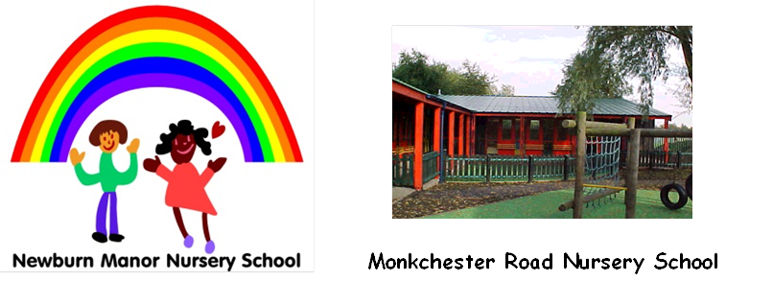



**Ashfield Nursery School**

1/5/2025

Dear Applicant

Thank you for showing an interest in one or all of the casual teaching assistant (Level 2 Grade 3) positions in our Federation

If you do apply please ensure you say which position you are applying for. You are also welcome to apply for all three positions– please mention that on your application – you do not need to fill in a separate application form.

Ashfield Nursery School is looking for a teaching assistant to work with children who have additional needs, sometimes this will be supporting them in class and sometimes following a timetable and supporting children in a quiet space with their individual targets. The days will be Monday and Tuesday 8.30 to 3.30pm. There could be additional days and times requested if needed.

Newburn Manor Nursery is looking for a teaching assistant to do some part times hours in our Playgroup (2-3 year olds). Your work may involve supporting a small key group of children as well as supporting children with additional needs.

Monkchester Road is looking for a person to work across the school with children aged 2-4, the hours are 8.45 to 4pm and will be Monday to Friday.

Please look at our websites to find out further information about each school.

Successful candidates will have a contract for our Federation of Schools. On occasion there may be possibilities for additional hours within any of our Nursery Schools.

The successful candidates will have experience of working with children aged 2 to 4 years in a school or private nursery setting. They will be caring and attentive to children’s individual needs and must have the skills and appropriate temperament to work as part of a strong and committed team, ensuring high expectations for all of our children.

Under the support of a class leader/teacher, successful candidates will take on a key worker role for a small group of children or will work with children with additional needs on a timetable. They will need to create safe and enabling environments that are fun and stimulating for all children, inside and outdoors.

Applicants require a thorough knowledge of the Early Years Foundation stage and how to apply this creatively, with enthusiasm so that every child meets their full potential. They will need to apply their skills, commitment and initiative to improve children’s learning in all areas of the Early Year’s curriculum.

Candidates will benefit from having worked with external agencies to support children with special educational needs and/or challenging behaviour. They will use a wide range of strategies skilfully and use a variety of classroom organisation techniques within a team teaching situation to provide exciting learning activities matched to the children’s next steps in their learning journey.

Candidates must be willing and able to work outdoors for much of their time, in all weathers.

We work closely with parents and the wider community so candidates will need suitable knowledge, skills and experience of working with families to support children’s learning and development.

Our Federation is fully committed to safeguarding children and applicants are required to complete several pre-employment checks and other activities that ensure they are safe and suitable to work with our young children. Our safer recruitment procedures include (but are not limited to) DBS checks and the taking up of two references before the interview process commences. One reference must be from the candidate’s current employer.

Closing Date- Friday 16th May (noon)

Shortlisting – After 16th May

Interviews week beginning 19th May

Please contact the school(s) if you are interested in the position or would like to arrange a visit.

Newburn Manor Nursery 0191 277 4180

Ashfield Nursery School 0191 273 5587

Monkchester Road Nursery School 0191 265 4579

If you are interested in this position, please download an application form from our websites.

[www.newburnmanor-nur.newcastle.sch.uk](http://www.newburnmanor-nur.newcastle.sch.uk)

[www.ashfield.newcastle.sch.uk](http://www.ashfield.newcastle.sch.uk)

[www.monkchesterroad.newcastle.sch.uk](http://www.monkchesterroad.newcastle.sch.uk)

All application forms and letter of application stating how you meet the person specification should be hand delivered or posted to either school before noon on 16th May.

|  |  |  |
| --- | --- | --- |
| **Ashfield Address** | **Newburn Address** | **Monkchester Road** |
| Jacqui Hamilton  Ashfield Nursery School  97-101 Elswick Road  Elswick  Newcastle  NE4 6JR | Samantha Walton  Newburn Manor Nursery School  Townfield Gardens  Newburn  Newcastle  NE158PY | Louise Grant  Monkchester Road Nursery School  Monkchester Road  Walker  NE6 2LJ |

Yours faithfully

Kay Mills Anne Humble

Federation Headteachers