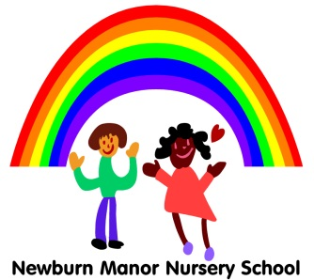
Newburn Manor Nursery School
Physical Development Policy

April 2017
Review April 2018

RATIONALE:
We believe that effective physical development helps children develop a positive sense of well-being. It is about:-
- improving skills of coordination, control, manipulation and movement
- helping children gain confidence in what they can do
- enabling them to feel the positive benefits of being healthy and active

PURPOSE 1:
To plan activities that offer appropriate physical challenges in an environment that provides enough space, indoors and outdoors.
GUIDELINES:
- Practitioners provide children with access to indoor and outdoor environments
- Children move spontaneously between these environments
- Where these environments are limited then practitioners arrange access to more suitable venues (park, community centre, local school hall etc.)
- Practitioners plan for the children to run, climb, balance, swing, slide, tumble, throw, catch and kick.
- Risk assessment procedures are carried out
- Safety is discussed with the children and their clothing checked
- Practitioners encourage and support children to become independent with their self-help skills.
- Practitioners encourage and develop fine motor skills eg the correct tripod grip to support drawing and writing skills.

PURPOSE 2:
To give sufficient time for children to use a range of equipment.
GUIDELINES:
- Planning allows for children to have sufficient time to persist and learn from their mistakes

PURPOSE 3:
To provide resources that can be used in a variety of ways or to support specific skills.
GUIDELINES:
- Resources include “small-world” toys, construction sets, threading and posting toys, shapes and materials for making as well as bikes, climbing equipment etc. so that there are opportunities for small and large movements
- Children are encouraged to take part in daily energetic activities as well as refining and practising skills
- Practitioners plan for movement using a range of stimuli, such as action rhymes, stories, music and props

PURPOSE 4:
To encourage independence in physical activities, using additional support (physiotherapists, occupational therapists etc.) to help individuals with physical disabilities or motor impairments.
GUIDELINES:
- Practitioners ensure that all children are encouraged to develop fine and gross motor skills
- Practitioners must pay careful attention to providing appropriate support for any children with mobility difficulties to ensure that they reach their full potential

PURPOSE 5:
To introduce the language of movement alongside the children’s actions.
GUIDELINES:
- practitioners use the vocabulary of movement and words of instruction

