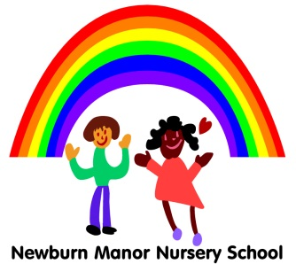
Newburn Manor Nursery School
Literacy Policy
April 2017
Reviewed April 2018

RATIONALE:
We believe that the development and use of communication through reading and writing are at the heart of young children’s learning and we provide a caring, supportive atmosphere in which the children have the confidence and motivation to use these in every part of the curriculum.

PURPOSE 1:
To provide opportunities for children to communicate thoughts, ideas and feelings through literacy.
GUIDELINES:
- Practitioners play alongside and observe children, and plan for the best contexts for them to develop reading and writing
- Practitioners encourage and value all attempts at communication [verbal/non-verbal/in any medium]

PURPOSE 2:
To incorporate communication and language development activities in each area of learning.
GUIDELINES:
- Planning incorporates daily phonics activities
- All activities are relevant to aspects of the children’s lives in the setting, at home and in the community and are based on purposeful play
- Planning incorporates the whole learning environment, indoors and outdoors, for individuals and small and large groups.
- Planning identifies explicitly how language will be used, the related vocabulary and opportunities for reading and writing in all areas of learning

PURPOSE 3:
To incorporate physical movement and practical experiences into literacy activities and to share a wide range of rhymes, music, songs, poetry, stories and non-fiction books.
GUIDELINES:
- Practitioners provide opportunities for physical action and plan for experiences which engage many senses
- Resources are yearly audited and purchased to maintain good quality and wide range
- Non-verbal communication is valued

PURPOSE 4:
To be aware of, and sensitive to, the needs of children for whom English is an additional language, using their home language when appropriate.
To plan opportunities for children to be aware of languages and writing systems other than English, and communication systems such as signing and braille.
GUIDELINES:
- Resources and toys reflect the diverse world in which we live
- Staff use photographs and symbols in addition to the spoken word to ensure access to all experiences
- Practitioners build on children’s experience of print at home
- Appropriate support and resources are made available for children with English as an additional language or who need alternative communication systems

PURPOSE 5:
To promptly identify and respond to any particular difficulties in children’s literacy development
Guidelines:
- Practitioners use assessment and recording to identify the needs of all children
- By October practitioners plan for, and if necessary seek advice for educational need
- Planning is shared by all practitioners and specific education plans established

PURPOSE 6:
To provide opportunities for children to see adults writing in an environment that reflects the importance of language through signs, notices and books.
GUIDELINES:
- Children become familiar with their own names
- Practitioners encourage children to label their own work and be pro-active with displays
- Practitioners plan to model writing and encourage the children to join in with taking the register, writing lists etc.

PURPOSE 7:
To encourage the children to experiment with writing, through making marks, personal writing symbols and conventional scripts.
GUIDELINES:
- The environment is organised to promote experimentation
- There are planned opportunities to encourage the need for writing

