REMOTE LEARNING DAY 7
Self-help
Explore weather appropriate clothing! Sort out Summer clothes (sun glasses, T shirt, sandals, flip flops, sun cream etc) and Winter clothes (hat, gloves, wellies etc) into two piles. Talk about when you would wear each item of clothing and why. You could extend by talking about water proof material, looking closely at the grippy soles on wellies and why they’re like that etc!
Try and dress a cuddly toy or doll in some of the clothing!

Gross motor

https://www.youtube.com/watch?v=KG3AO6lJ4BQ
Have fun watching The Bear Walk video and copying the actions!

Fine motor / muscle stamina (mark making)

Design some Winter jumpers! (see the template below)
Draw patterns such as zig zags, wriggly lines, spots, lines up and down/side to side
OR draw some Winter pictures such as a Snowman. Have a go at writing your name on one of your jumper designs. Remember to try and hold your pencil using a pincer grip at the bottom of your pencil.

Beat Baby
Its time to meet Beat Baby! Some children may have met him already but for others they will be meeting him for the first time! Beat Baby is a cuddly toy we use in nursery to help us sing songs whilst clapping/tapping/stomping the beat or rhythm. Words can be divided into syllables (chunks of sound) and the rhythm in a song often reflects the syllables in the lyrics. Helping children to identify syllables by highlighting them through music is an effective method of helping children to break down words. Adding movement too, to highlight the syllables, adds further emphasis.
Follow the link below to watch the video of Mrs Howell singing with Beat Baby and have fun joining in! Welcome to Newburn Manor Nursery School (newburnmanor-nur.newcastle.sch.uk)
Maths link – Clap syllables for objects around your home. How many claps/syllables do they have?
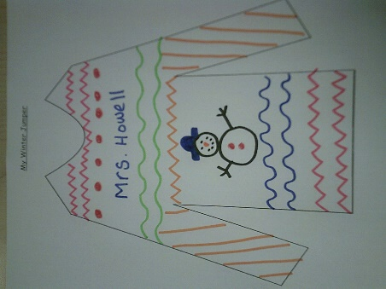
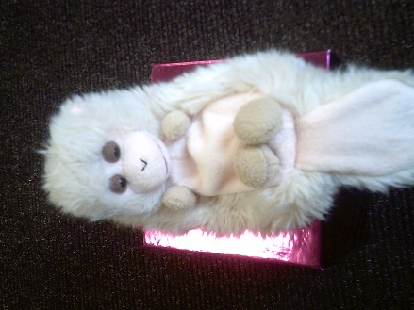

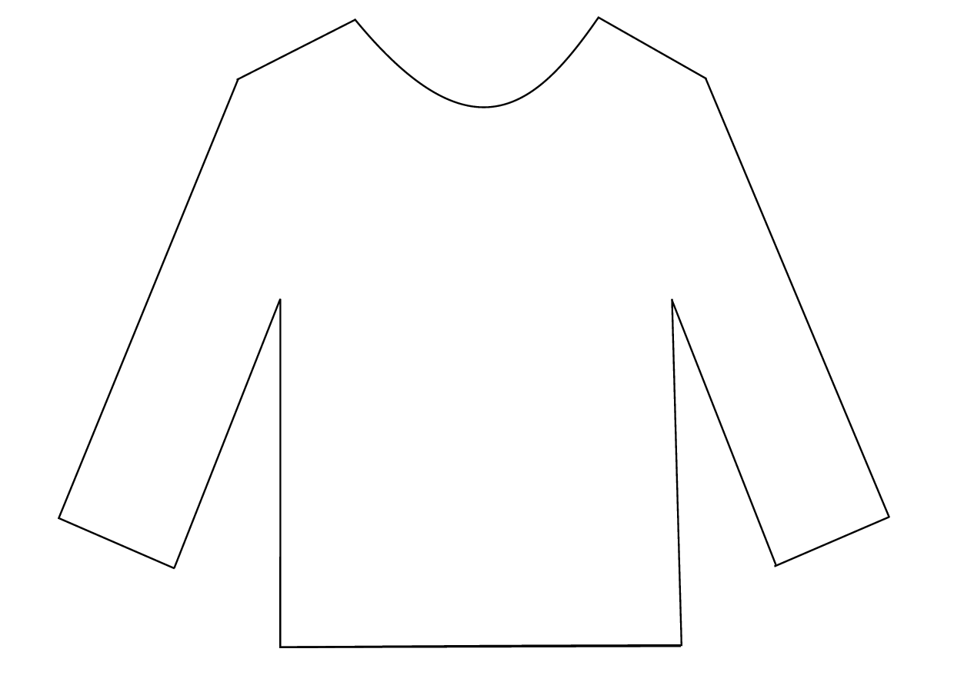
My Winter Jumper

