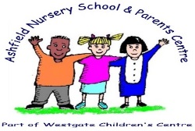

Ashfield Nursery School



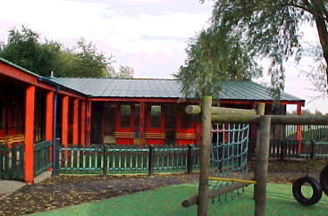 **Monkchester Road Nursery**

**Newcastle Nursery Schools Federation**

**Behaviour Principles Written Statement**

**September 2019**

The Governors of our three Nursery Schools within Newcastle’s Federation of Nursery Schools (Monkchester Road, Ashfield and Newburn Manor) believe that the best way to manage behaviour is to promote positive behaviour.

This is clearly identified in each school’s behaviour policy.

The following statement has been agreed by staff and Governors

Our federation believes that:

* The learning environment is established to promote positive behaviour, it needs to be pleasant and calm to enable children to learn and socialise together.
* Children are encouraged to treat each other with care and respect.
* Children should be encouraged to co-operate with each other as well as staff
* Children’s confidence, self-esteem and self-discipline needs to be developed in an atmosphere of mutual respect and encouragement.
* The children flourish best when their personal, social and emotional needs are met and there are clear and developmentally appropriate expectations for their behaviour.