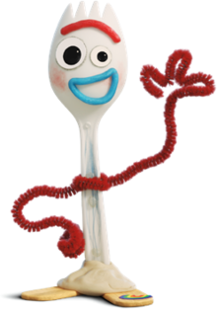
REMOTE LEARNING – Thursday 4th February

“Hello everyone, how are you, how are you today?”

Today, I’m feeling a little bit grumpy because I would really like to go for a long walk but it’s raining again! Maybe I’ll put my wellies and rain coat on and go for a rainy walk and jump in the puddles?! It will cheer me up.

Self help
Calling all Superheroes, it’s Challenge time! How quickly can you get dressed or undressed? First, you need to decide if you’re going to get fully dressed or undressed OR you might want to take your jumper or coat on or off? You can choose which one you’re best at as you’re trying to be as fast as you can! Next, decide who is going to count? Can you count AND do the challenge? Or will a grown-up count for you? If you’ve got a timer then you might like to use that? Can you press the button to start and stop the timer? ……. ready, steady and off you go!
Did you win the challenge? The teachers would love know how you got on?!

Fine motor / muscle stamina
Goldilocks AND the three bears love eating porridge! Porridge is made from oats. First, put some oats in a bowl and get those fingers ready to feel the oats! How do they feel? Bumpy? Smooth? Soft? Shiny? Wrinkly? Hard? Now, take a handful of oats and put them on a tray and give the tray a gentle shake so that they’re all spread out. Finally, can you use your fingers to make marks in the oats. Put your looking eyes on, can you see what I’ve drawn in my oats?!

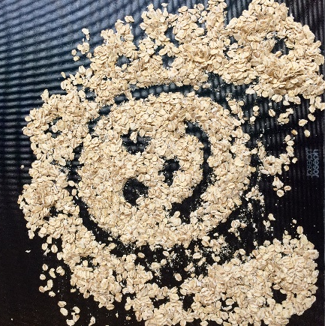
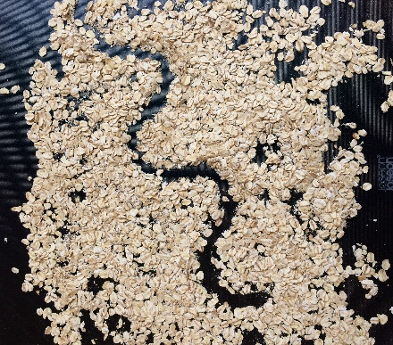
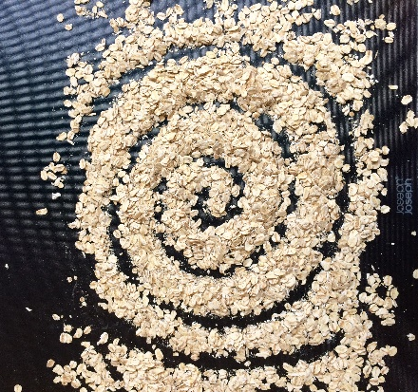
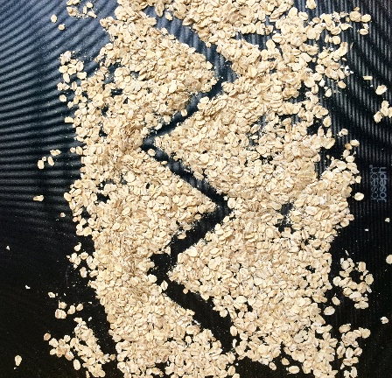
A character from the story?! Waves Zig zags Spirals

We can’t wait to see what marks your fingers can make?

Gross motor
Time for an exercise challenge Superheroes ……
Roll a dice, count the dots and do the exercise that many times! Your exercises are:

Hopping Jumping Pencil rolls Tiptoeing
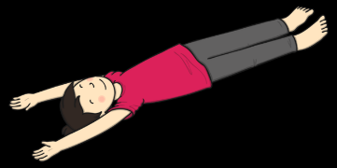

Song time
Pop your singing voice in because it’s song time …….
Yesterday, Mrs Henderson kindly read us ‘Goldilocks and the Three Bears’. Today, we’re going to learn a song all about the story. Please click on the link below:
https://www.bbc.co.uk/teach/school-radio/nursery-rhymes-when-goldilocks-went-to-the-house-of-the-bears/zbkrf4j

