REMOTE LEARNING DAY 6

Self-help and Fine motor / muscle stamina
~ Shoes and socks off and on
Can your child take their shoes off all by themselves? Start by encouraging your child to undo the velcro fastener and pull their shoe from the heel. Can you take your socks off without any help? It’s much trickier to put socks and shoes on so take it step by step and begin with a sock on the toes only and encourage your child to pull it up. For shoes, remind your child to open up the foot opening by, for example, opening the velcro fastener.

Gross motor and Song time
~ Action songs
Have a good boogie and a sing song with these well known songs
- Row, row, row your boat
- The Grand Old Duke of York
- Head, shoulders, knees and toes
- If you’re happy and you know it

And if you don’t know them then your child will as they’re all songs we love to sing at nursery!

Pets
It’s time for something new, it’s time to learn about Pets!
Have you got a pet?
Don’t worry if you haven’t, you can easily make a pretend pet using an old sock for a sock puppet? Mrs Barnard hasn’t got a pet at home so meet Nala, her new pet!

We would love to hear all about your pets and sock puppets so please share them with us!
Here are some of the staff pets… Can you match the pets to the owners? If anyone manages to match all of the pets to their names and the owners, Mrs Stephenson will have a special surprise prize for the winner! (it is so good a surprise that even she doesn’t know what it will be yet!!)

Mrs Dodds has 2 pets. They are called Aggie and Nell. | Mrs Stephenson has 5 pets.  They are called, Phoebe, Lola, George, Smudge and Doodles. | Mrs Henderson has 1 pet. He is called Marlin. | Mrs Reid has 4 pets. They are called Beatrice, Merida, Swishy and Bourbon.
Mrs Howell has 3 pets. They are called Archie, Henry and Rolo. | Mrs Young has 4 pets, Itsy, Rosie, Lola and Isla | Mrs Mills has 2 pets. They are called Blu and Scout. | Mrs Cook has 1 pet. He is called Wilson
Miss Ritzema has 2 pets. They are called Hugo and Ralf | 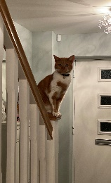 | 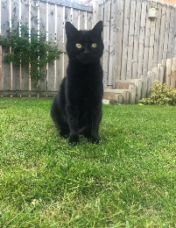
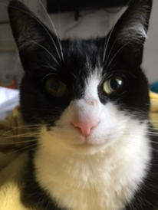 | 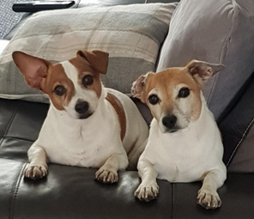 | 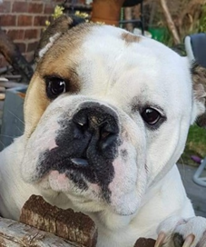 | 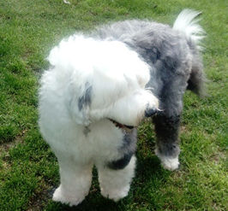
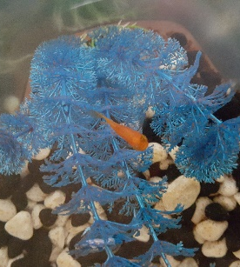 | 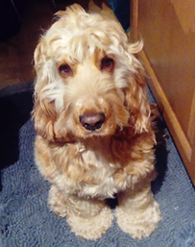 | 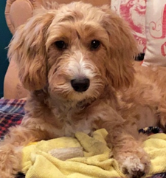 | 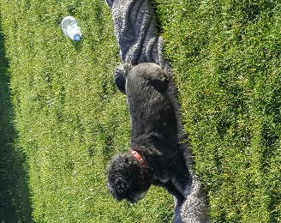
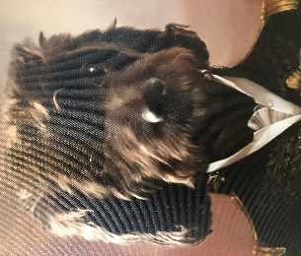 |  | 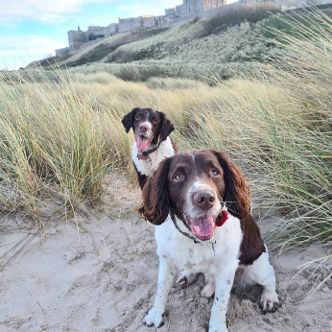 | 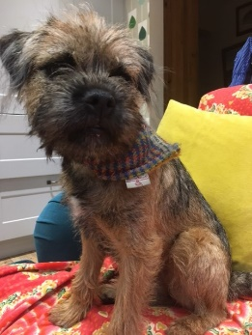
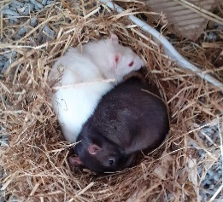 |  |  | 