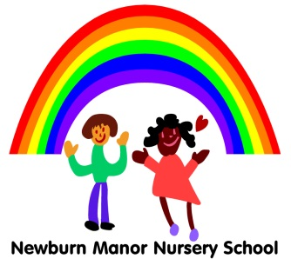
British Values - Newburn Manor Nursery School

As part of our broad and balanced Curriculum we actively promote British Values in the Nursery. We encourage children to be respectful and tolerant of each other. British Values are embedded within our curriculum particularly in the area of Personal, Social and emotional development. We also plan additional activities over the year to promote British Values.
These are some examples of how we promote British Values in Newburn Manor Nursery School:
Democracy
- On arrival to Nursery children complete their planning cards – they discuss with their parents where they would like to play and what they would like to do there.
- Each day children are encouraged to talk about their feelings, they spend time before having fruit discussing how they are feeling. Children make a tally of how others are feeling in the group so this can be sung in the group song. Children understand the use of tallies and know it helps to count a vote.
- Staff encourage conflict resolution by working out with children what has happened and encouraging a way round i.e sharing, taking turns, negotiating roles in play – this helps children to become more sensitive to the feelings and needs of others.
- Children are always listened to by staff and are encouraged to listen to each other – this encourages the children to understand they are valued and have a valuable contribution to make.
- Investing in Children – Listening to Children Award
Rule of Law
-Children are encouraged to understand what is right and wrong through reinforcing of how to behave in Nursery. Children are given praise for their good behaviour.
-The children follow a daily routine and understand about having ways to behave – i.e tidy up time.
- Soft toys ‘Dossie’ and ‘Kwame’ are used in group time to support learning about what is right and wrong and how to make the right choices.
- Through the area of learning ‘Understanding the World’ children learn about communities and people who help us – eg police and firefighters.

Individual Liberty
- Children are encouraged to make their own choices in Nursery and know they are supported.
- Staff praise and encourage children’s effort and achievements to help them develop a positive image of themselves and increase their self-esteem and confidence.
- Special helpers are chosen at group time which helps to develop confidence and self-esteem.
- Children’s work is appreciated and shared in a book helping to develop a positive sense of themselves and their achievements.
- Children are made aware that we can have different opinions eg – discussion about starting Reception class – how do children feel about this.

Mutual Respect and tolerance of those with different faiths and beliefs
- We create an ethos of tolerance, appreciation and respect for others. Children understand that we all have similarities and differences – eg narrowing down who the special helper is to respecting differences in children – eg speaking different languages or using makaton.
- We understand that all children develop at different rates and have different needs.
- Staff challenge stereotypes when they occur and ensure resources reflect a rich and diverse society.
-Staff model speaking respectfully and listening to everyone, particularly at group time.
- Group time discussions are planned to talk through our similarities and differences eg – Christmas.

