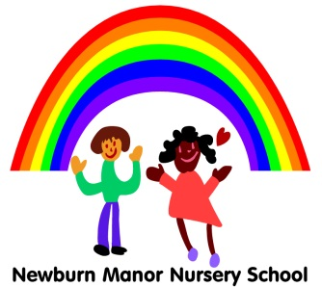
Newburn Manor Nursery School
Expressive Arts and Design Policy
April 2017
Reviewed April 2018

RATIONALE:
We believe that creativity is fundamental to successful learning as it enables children to make connections between one area of learning and another and so extend their understanding. This area encompasses art, music, dance, role-play and imaginative play.

PURPOSE 1:
To provide a stimulating environment in which creativity, originality and expressiveness are valued.
GUIDELINES:
- Practitioners provide access to a wide range of stimuli and ideas.
- They value the work of children at whatever level they are working.
- Practitioners provide an attractive, interactive environment, with easily accessible areas for creative work.
- Practitioners encourage children to label their work and to take pride in its presentation.

PURPOSE 2:
To provide quality resources, including those from a variety of cultures, to encourage children to think in different ways and to express ideas through a wide range of types of representation, so accommodating children’s specific cultural or religious belief.
GUIDELINES:
- Practitioners provide general access to good quality materials and examples of work to stimulate children’s curiosity and encourage exploration and experimentation in different ways.
- In line with the school’s Equal Opportunities and Knowledge and Understanding of the Work Policies, all resources will reflect a wide range of cultures, beliefs and traditions.
- In daily review sessions children share and evaluate their own work and that of others. Encouraging empathy, sensitivity and an appreciation of quality.

PURPOSE 3:
To provide a wide range of activities that children can respond to with all their senses, making appropriate provision for those children with sensory impairment of any kind.
GUIDELINES:
- Throughout the range of learning areas, practitioners plan for activities which encourage children to be creative in different ways, using a variety of media and involving all senses.
- Access is provided to all activities for children with SEN, by the use of appropriate resources and adaptations to equipment.
- Practitioners may directly teach new skills, encouraging children to integrate them into their own work so creating something new.

PURPOSE 4:
To give children experience that involves exploring and using a wide variety of media.
GUIDELINES:
- Activities are planned to help children understand the capabilities of different materials and the concept of change.
- Children are taught safe handling of materials and tools.
- Children are taught techniques of mixing, joining and combining.
- Children are taught safe use of tools.

PURPOSE 5:
To give sufficient time for children to explore, develop and finish working at their ideas.
GUIDELINES:
- Practitioners plan to give children sufficient time to explore, experiment and refine; to practise and consolidate skills and ideas.
- Encourage children to plan and be independent, to respond to their own stimuli and to review their work.

PURPOSE 6:
To provide opportunities for children to work alongside artists and other creative adults.
GUIDELINES:
- Governors and Staff are committed to allocating funding (when viable) to employ specialists in all areas of creativity, so children may gain from first-hand experiences, using a variety of techniques and media and encouraging the development of confidence in their own creativity.
- Practitioners work alongside the children acting as role models, allowing discussion of their work so developing children’s understanding of the creative process.

