Remote Learning – Wednesday 10th February

Hello everyone!! Today is Wednesday and we’re going to be thinking about Valentine’s Day which is happening next week! What do you know about Valentine’s Day? It’s all about love hearts and love! It might be nice to do something kind for someone in your family on Valentine’s Day to show them how much you love them. You could tell them you love them or even make them an ‘I Love You card’
Here are some cards that I made. One of them was made by tearing and cutting little bits of paper then sticking them with glue in a heart shape. The other was made by using a heart shaped toilet roll tube stamper. Maybe you would like to make a similar card? Who is it going to be for? Try and copy their name and then remember to write your name too so they know who it’s from! I’m sure you’ll do a good job at remembering to use your pinchy fingers at the bottom of your pencil when writing!
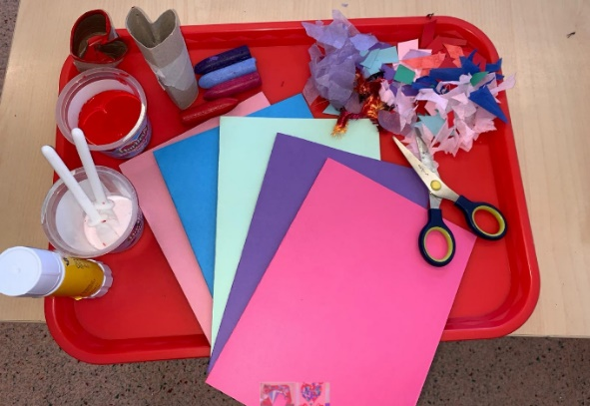
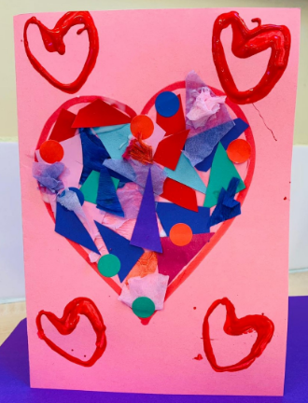

Self Help
Could you be kind to someone in your house by helping them. Could you help make them a snack like a smoothie or a sandwich (with grown up support) OR could you help by sweeping up using a dustpan and brush….or dusting….or sorting laundry into piles….or sorting socks into pairs etc?

Gross Motor
Practice having a Valentines Disco! Find your favourite songs about love and have a boogie!

Story
Guess how much I love you by Sam McBratney. Grandma Annii's Storytime - YouTube

