REMOTE LEARNING – Friday 5th February

“Today is Friday, today is Friday.
Is everybody happy?
You bet your life we are?”

Today, I’m feeling excited because Mrs Henderson has been bird watching all week and here’s one of the birds that visited her garden!

Can you spot anything with your good looking eyes? What sort of bird is it? The colour will give you a clue!
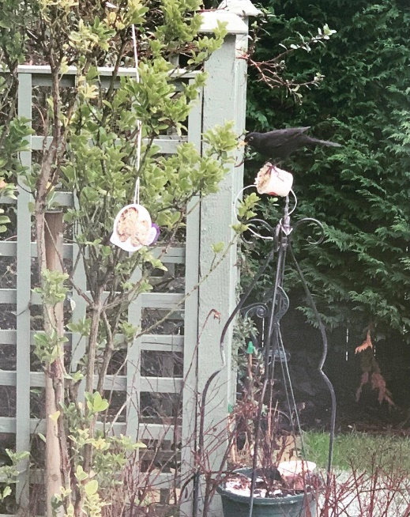
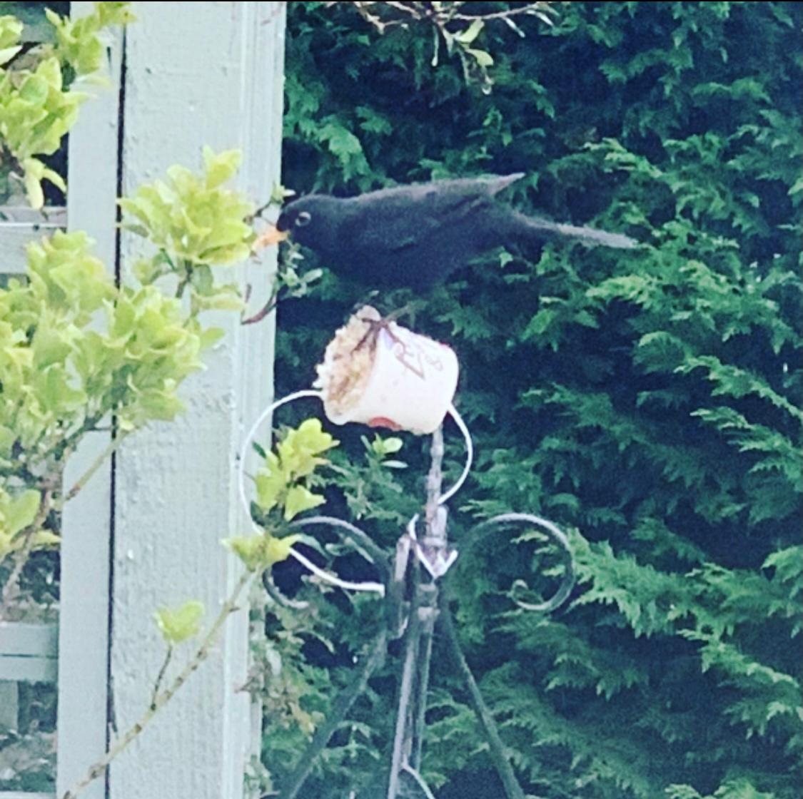

Self help and Gross motor
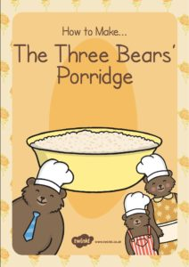
We’ve been learning about ‘Goldilocks and the Three Bears’ all week and I haven’t had porridge yet for my breakfast! So today, it’s time to make some tasty porridge! Here’s a ‘Goldilocks and the Three Bears’ porridge recipe to try with your grown up: https://www.twinkl.co.uk/resource/t-t-20145-the-three-bears-porridge-recipe-cards

Fine motor / muscle stamina
Time to get creative everyone ……. Mrs Henderson has been learning about texture this week at home, just like you! She searched outside and in her house for things to feel. Just look at these amazing pictures that Mrs Henderson has made with what she found! Can you switch on your looking eyes and see what she has used to make her pictures? I think you’ll be surprised!?

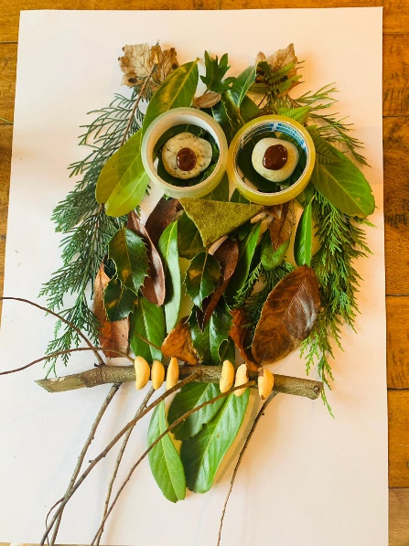
I spy with my little eye ……. an owl made with leaves, twigs, tape, and are those nuts I can see? So many things to find!

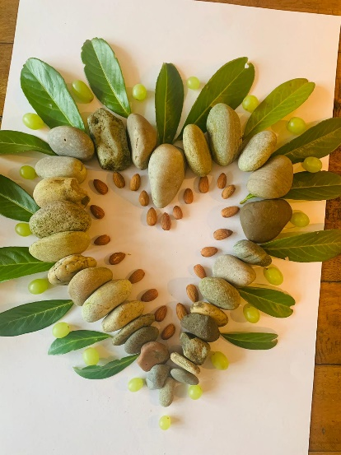

I spy with my little eye ……… a heart made with stones, leaves and nuts! Wow!

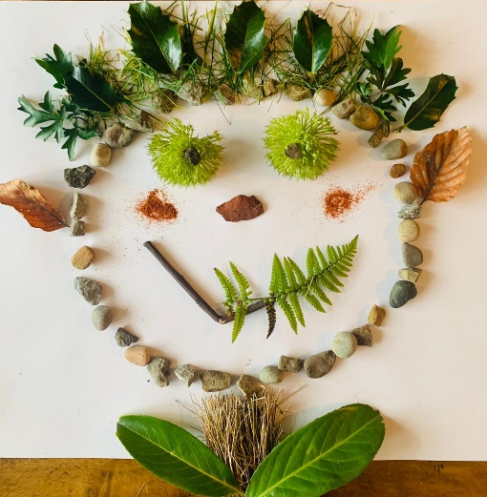

I spy with my little eye …….. a troll! Let me introduce you to
Tex the texture troll! He lives in Mrs Henderson’s garden!

When Mrs Henderson touched the things she found outside she said they felt “hard” “crispy”, “soft”, “wet”, “crispy”, “soggy” and “spiky”.
And here are the creations that Mrs Henderson made from the texture objects she collected on her house hunt!
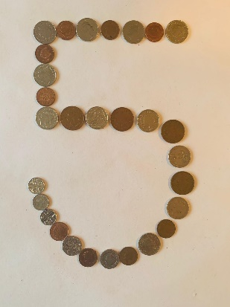

I spy with my little eye …. a number 5 made with coins!

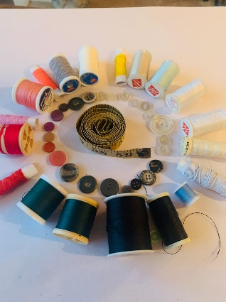

I spy with my little eye …. a spiral made with buttons and bobbins!

Have a go yourself and enjoy creating! The teachers are excited to see what you make so please send us some photos!

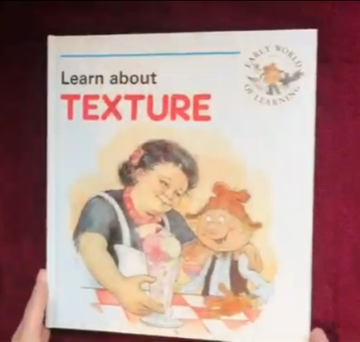
Story time
Our story today is all about texture, it’s the perfect way to end our week of learning about texture!
There’s something else in the story that we’ve been learning about whilst at home? I’ll give you a clue … they can fly?!
So switch on your listening ears and looking eyes ….
https://www.youtube.com/watch?app=desktop&v=SKvrrpr7s_Q

Have a happy weekend everyone! I’ve heard that it might snow, yippeeee?!

