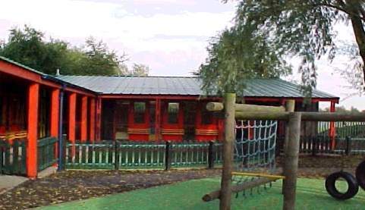
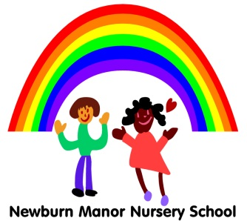
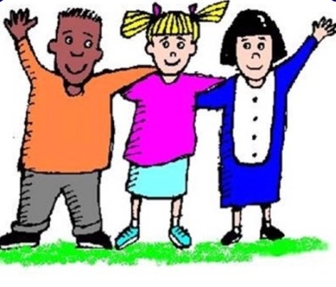
Monkchester Road Nursery School

Newcastle Nursery Schools’ Federation

Ashfield Nursery School

Newcastle Nursery Schools’ Federation
Food Allergies & Intolerance Policy 2025
To be reviewed Annually – Autumn 2026

Aims
To keep children in our care as safe as possible by reducing the risk of exposure to known allergens.
To support inclusivity so that children with food allergies or intolerances can participate safely in all aspects of nursery life (meals, snacks, cooking activities, parties, etc.).
To ensure that staff understand their roles and responsibilities in managing, preventing, and responding to allergic reactions.
To comply with statutory requirements under EYFS (Safeguarding & Welfare) and relevant food safety / allergen labelling laws.
To provide information to parents/carers regarding how we manage and promote allergy awareness and risks in our nurseries

Legal and Policy Framework
Under the EYFS Safeguarding & Welfare requirements, early years providers must ensure children’s health needs are met, including dietary requirements.
From September 2025, providers must have regard to the new EYFS nutrition guidance, unless there is good reason not to.
Our settings comply with food safety and allergen labelling laws: since 2014, food businesses must provide details about 14 specified allergens in foods they serve. Our settings follow good practice as outlined by Allergy UK, Anaphylaxis UK and other expert bodies.

Definitions
Within this policy, the following definitions apply:

Allergy: an adverse, usually immune-mediated reaction to a specific food or ingredient (allergen).
Intolerance: a non-immune-mediated adverse reaction (e.g. lactose intolerance) which is generally less immediately dangerous but still requires management.
Anaphylaxis: a severe, life-threatening allergic reaction that requires urgent medical intervention (e.g. epinephrine/adrenaline).
Allergy/Intolerance Action Plan (and/or Health Care Plan): a written plan, agreed with parents/carers (and paediatrician/allergy specialist, health professionals where necessary). This plan explains the known triggers that affect each individual child, their symptoms and known reactions, medication, and emergency procedures for treating their specific allergy and circumstances.
Allergen: a component (ingredient) in food that triggers the allergic reaction. In the UK there are 14 recognized allergens which must be labelled when used in foods. The 14 known allergens that staff must be aware of are:
Celery | Cereals containing gluten (eg Wheat, rye, barley oats) | Milk | Eggs | Soya
Fish | Crustaceans (e.g., prawns, crabs, lobsters) | Molluscs (e.g., mussels, oysters), | Mustard | Lupin
Peanuts | Sesame Seeds | Tree Nuts (almonds, hazelnuts, walnuts) | Sulphur dioxide and Sulphites
Registration, Information & Assessment
Registration / Admission
At enrolment, parents/carers must complete a medical/dietary information form asking explicitly about known allergies and intolerances
Keyworkers follow up any information about allergies or intolerances with parents at parents’ meetings and during home visits.
Keyworkers seek parental consent to share relevant allergy information (including photographs) with staff in key areas of our settings (kitchen, classrooms, first aid) to support safe management.

Risk Assessment / Planning Meeting
Before a child with a known allergy starts in our settings, keyworkers meet with parents/carers to review their dietary needs and agree a Health Care/Allergy Action Plan to mitigate against known allergies and manage them in school. Where relevant and in more complex cases, health professionals may attend a Health/Allergy Care Meeting with staff to support a child’s allergy needs and management.
Keyworkers complete risk assessments for children with known allergies. These cover and include all nursery activities involving food: meals, snacks, cooking, food-related craft, parties, excursions, birthdays, etc.
Each child has a named keyworker who takes oversight of the child’s allergy plan. Named key workers liaise with parents and ensure communication with all other staff about the child’s allergies and any related needs or management procedures.
Keyworkers maintain records of meetings with parents/carers, complete allergy/health care plans and emergency procedures. A copy is kept in the child’s classroom and a copy is stored centrally in the main office following Data Protection procedures as required.

Review and Updating of Allergy/Health Care Plans
Allergy information for individual children must be reviewed regularly (e.g. at least annually) and whenever there is any change in the child’s condition or treatment.
Parents must inform the nursery immediately of any changes in medical condition, diagnosis, or medication.

Staff Training, Competencies and Responsibilities
Training
All staff must receive regular training (at least annually) in allergy awareness, recognition of allergic symptoms, avoidance of allergens, and emergency procedures (including use of epinephrine auto-injectors if applicable).
New staff (or temporary/substitute staff) must be briefed on the allergy policy and child-specific plans before working in areas where food is served or consumed.
Staff should be familiar with the 14 UK allergens and common cross-contamination risks.

Roles and Responsibilities

Co-headteachers of our Federation:
- oversee the allergy policy, updates, and compliance
- ensure staff training is up to date.
- liaise with parents, governors, medical professionals, caterers, and external providers to ensure safe practice.
- audit incidents and near misses and review procedures accordingly.

Named Keyworkers (of children with allergies)
- maintain the child-specific Allergy Action Plans, ensure they are accessible to staff (kitchen, classrooms).
- ensure during mealtimes/snack times the correct food is given to the child, and no cross-contamination occurs.
- check food used in school, it’s storage, preparation, and serving/usage to avoid allergen exposure.
- manage storage, recording and administration of emergency medications in line with each child’s allergy/health care plan

All Staff/Practitioners
- will familiarise themselves with children’s allergy plans and are vigilant in routine practice
- at mealtimes, check that each child is given the correct food, and avoid any swapping or sharing of food
- are alert to signs of allergic reaction and respond according to emergency procedures
- maintain high standards of hygiene (handwashing, cleaning, separate utensils)

- report any incidents or near misses immediately to Co-Headteachers or Designated Safeguarding Leads

Food Provision, Preparation and Serving

Menu Planning and Allergen Safety
The nursery kitchen (or external city council caterer) must record, for every dish, which of the 14 allergens are present or may be present via cross-contamination (e.g. “may contain traces of …”).
Staff should promote inclusion and aim to offer safe alternative meals for children with allergies that are as similar as possible to the meals served to other children
Staff regularly check ingredient labels of purchased foods (ingredients can change) to ensure they remain free of the relevant allergens

Cross-Contamination Controls - followed by all staff
use separate utensils, chopping boards, pans, and protect surfaces when preparing allergen-free meals.
clean surfaces and equipment thoroughly between uses; ensuring they wash their hands before and after handling allergenic foods.
store allergenic foods separately and clearly label them.

During Serving/Mealtimes/Snack-times
A designated staff member must check that each child’s meal is correct (i.e. free from their known allergens) before it is served.

Keyworkers should supervise children carefully during mealtimes, all children and staff should be seated. (staff facing children, staying aware of food swapping or exchange).

Keyworkers should be sitting to eat and never walk around the setting eating, keyworkers are role models for children, they are asking the children to sit at snack times and meal times so they must do the same.

Keyworkers must not share their food with children.

Activities with Food (Cooking, Baking, Craft)
Staff consider allergen-safe alternatives when planning cooking or food-related activities.

Staff ensure children with food allergies are safe to participate (or provide alternative tasks) and maintain vigilance against contact with allergens.

Staff clean all surfaces and utensils thoroughly before and after such activities.

Special Events, Celebrations, Birthdays
The nursery should have guidelines on safe snacks for parties (e.g. no foods containing allergens, or parent-provided safe options).

Our settings encourage non-food-based rewards or celebrations (stickers, activities, etc.).
If parents bring food items into nursery, staff ensure prior approval and checking against allergy plans and avoid last-minute food contributions without review.

Recognition and Response to Allergic Reactions

Recognising Symptoms
Staff must be aware of the signs of food allergy reactions, which may include (but are not limited to):
- Itching, hives, rash, swelling (face, lips, tongue, throat)
- Respiratory symptoms (wheezing, difficulty breathing)
- Gastrointestinal (vomiting, diarrhoea, cramping)
- Drop in blood pressure, dizziness, collapse
- Anaphylaxis (multi-system, rapid onset)

Emergency Response/First Aid
Follow the child’s pre-determined Allergy Action Plan (which may include administering epinephrine/adrenaline auto-injector).

Immediately call emergency services (999 or local equivalent) when anaphylaxis is suspected, even if symptoms seem to improve.

Monitor the child continuously until help arrives.

Contact parents/carers or emergency contacts as soon as possible.

After any allergic reaction, complete an incident report, inform parents immediately, and review practice / risk assessments to reduce future risk.

Medication Storage and Administration
Prescribed medication (e.g. epinephrine auto-injector) must be stored in a safe but easily accessible place known to all key staff.
Keyworkers ensure medication should not be locked away in a cupboard that is inaccessible during an emergency.

Any staff authorized to administer epinephrine must be clearly identified and trained. Staff make sure medical records are kept up to date. This includes a record of when reviews will take place and when each child’s medication is due to expire - so they can ensure parents supply replacements in time.

Incident Recording, Reporting & Review

Incident Reporting and Records of Near Misses
Any instance of a suspected allergic reaction, or a near-miss (e.g. allergen exposure, incorrect food given but no reaction) must be documented immediately.

The incident/near miss report should include date, time, staff present, location, food involved, actions taken, outcome, and witness accounts.

Analysis and Follow-up of Incidents/Near Misses
Co-Headteachers or designated leads will review all incidents and near-misses to identify root causes (e.g. procedural lapses, miscommunication, labelling errors) and update risk assessments or procedures accordingly.

Share findings (in anonymised form as needed) with staff to improve practice.

Informing Parents/Stakeholders
Keyworkers inform the child’s parents/carers immediately of any allergy reactions or near-misses.

Co-Headteachers or Designated Leads report any incidents/near misses to relevant bodies as and when required (e.g. local authority, health & safety, governors).

Communication and Awareness

Staff Communication
Allergy plans should be accessible to all relevant staff (classrooms, kitchen, first aid, director’s office).

Staff meetings should include review of allergy-related practice and refreshers.

Communication with Parents/Carers
The nursery should publish the allergy policy (e.g. in the welcome pack, website) so families understand expectations and procedures.

Encourage open communication: parents should raise concerns and update information as needed.

Children’s Understanding (Age-Appropriate)
Where appropriate (age 2–4), children can be gently taught about not sharing food, washing hands, and awareness that “some foods may make some children unwell.”
We encourage a culture of respect and safety rather than fear or stigma.

